Smart Robot Design and Demonstration



Team Design Project and Skills Final Report

Team 41 "Furious"

1. Abstract

Smart robots have become an indispensable facet of present-day life, offering a convergence of technological advancements and advanced features. These robots can operate a diverse range of tasks and have substantially impacted people's daily work. The Team Design Project and Skills (TDPS) aim at working collaboratively on the design and construction of smart robots. The team's primary objective is to create a robot with integrated electronic systems that can perform specific functions. With ten students pooling their skills and efforts, the team aims to efficiently achieve its goal. The team has complete flexibility to choose appropriate hardware components that align with their blueprint while operating within a designated budget.

The design and anticipated outcomes of the robotic car is capable of performing distinct tasks on two separate patios. The robotic car incorporates three fundamental systems: the Sensor System, Executive Control System, and Wireless Communication System. The Sensor System combines a visual processor, ultrasonic sensors, and an accelerometer and gyroscope module to enable shape detection, distance measurement, and precise motion control. The Executive Control System integrates a microcontroller, robotic arm with a servo actuator, and motor drive circuit, enabling signal processing, arm control, and motor driving. The Wireless Communication System facilitates seamless transmission of essential data to a laptop using a wireless transceiver. Through the harmonious integration of these advanced systems, the robotic car is expected to demonstrate seamless operation, versatility, and accuracy in executing tasks on both patios, showcasing its effectiveness and contributing to the desired outcomes.

The successful implementation of the robotic system was a collective effort, with each team member contributing to the development of subsystems and integration of the overall robot control system. The project management was excellent, facilitated by a well-coordinated team schedule that ensured timely completion of tasks. This project has provided invaluable teamwork experience for each team member, highlighting the importance of collaboration and coordination in achieving project goals.

1. Acknowledgement

正文

1. Contents

Abstract I

Acknowledgement II

Contents III

Abbreviation V

List of Figures VI

List of Tables VIII

1. Introduction 1

1.1. Background 1

1.2. Task Analysis 1

1.2.1. Patio 1 1

1.2.2. Patio 2 2

1.2.3. General Rules 3

2. Top-level Structure Design 3

2.1. Sensor System 3

2.2. Executive Control System 4

2.2.1. Wireless Communication System 5

3. Implementation 5

3.1. Sensor System Implementation: Detection for Patrol and Adjustments 5

3.1.1. Visual Processor 5

3.1.2. Ultrasonic Ranging Sensor 6

3.1.3. Accelerometer and Gyroscope 8

3.2. Executive Control System Implementation: Robot Control and Operation 9

3.2.1. MCU 9

3.2.2. Power Regulator Circuit 10

3.2.3. Battery Monitoring Circuit 12

3.2.4. Motor Drive Circuit 13

3.2.5. Motors 14

3.2.6. PCB 15

3.2.7. Mechanical Arm 17

3.3. Wireless Communication System Implementation: Message Delivery 19

3.3.1. HC-12 19

3.3.2. UART 20

3.3.3. Wireless data transmission 21

3.3.4. DS1302 Clock Module 21

3.4. Peripherals 22

3.4.1. OLED 22

3.5. Robot Mechanical Structure 23

3.6. System Integration 27

3.6.1. Patio 1 27

3.6.2. Patio 2 32

4. Results and Discussion 33

4.1. Arrow Identification 33

4.2. Line Patrol 33

4.2.1. Straight Line Movement 33

4.2.2. Crossing the stone road 34

4.2.3. Turning 34

4.3. Wireless Communication 34

4.3.1. Communication message garbling problems 34

4.3.2. How to start sending messages 35

5. Conclusion 35

References 36

Appendix 37

A. Gantt Chart 37

B. Programming 37

B.1. Ultrasonic Sensors 37

B.1.1. Ultrasonic Sensors Definition 37

B.1.2. Ultrasonic Sensors Header File 38

B.2. Accelerometer and Gyroscope 41

B.2.1. Accelerometer and Gyroscope Definition 41

B.2.2. Accelerometer and Gyroscope Header File 43

B.3. Patio 1 Main Program 43

C. Project Management 50

1. Abbreviation

|  |  |
| --- | --- |
| Abbreviation | Full Name |
| AC | Alternating Current |
|  |  |
| ADC | Analog-to-Digital Converter |
| DC | Direct Current |
| LED | Light-Emitting Diode |
| LCD | Liquid-Crystal Display |
| MCU | Micro Controller Unit |
| NC | Normally Closed |
| OLED | Organic Light-Emitting Diode |
| PWM | Pulse Width Modulation |
| PCB | Printed Circuit Board |
| PVC | Polyvinyl Chloride |
| TV | Television |
|  |  |
|  |  |
|  |  |

1. List of Figures

Figure 1. Patio 1 tasks. 2

Figure 2. Patio 2 tasks. 3

Figure 3. Sensor system. 4

Figure 4. Executive control and wireless communication system. 5

Figure 5. The pinout of OpenMV [1]. 6

Figure 6. Installation and setup of the HC-SR04 modules. 7

Figure 7. HC-SR04 pins and pin names [2]. 7

Figure 8. Results of successful measurements with the HC-SR04. 8

Figure 9. Nucleo-G474RE pin names and pinouts. 10

Figure 10. The power regulated circuit. 11

Figure 11. The battery monitoring circuit. 13

Figure 12. Motor drive circuit schematic. 14

Figure 13. The PCB board wiring. 15

Figure 14. The front and back of the PCB. 16

Figure 15. The extension board wiring. 16

Figure 16. The front and back of the extension board. 16

Figure 17. The front and back real shots of PCB and extension board. 17

Figure 18. 3D-printed claw. 17

Figure 19. SG90 servo. 18

Figure 20. 3D printed connector. 18

Figure 21. Slider design drawing. 19

Figure 22. The overall mechanical arm. 19

Figure 23. Displaying texts successfully using an OLED. 23

Figure 24. Acrylic panel. 24

Figure 25. Chassis of the robot. 24

Figure 26. The schematic diagram of the structure of the first layer. 25

Figure 27. The frame to hold the OLED and the switch. 25

Figure 28. The schematic diagram of the structure of the second layer. 26

Figure 29. The schematic diagram of the structure of the third layer. 26

Figure 30. Triangular plate for connecting and fixing PVC pipes. 27

Figure 31. The final assembled robot. 27

Figure 32. Patio 1 scene layout and partial action track. 28

Figure 33. Line tracking in phase 1 of patio 1. 28

Figure 34. Ultrasonic recognition of obstacles and 90 degree turns. 29

Figure 35. Traveling forward again for 1.2s and stopped, adjusting the forward direction. 29

Figure 36. Getting on the bridge. 30

Figure 37. Crossing the bridge. 30

Figure 38. Line tracking after getting off the bridge. 31

Figure 39. Passing through the gate. 31

Figure 40. The patio 1 flow diagram. 32

Figure 41. Patio 2 tracked route. 33

Figure 42. Patio 2 – the stone road. 34

1. List of Tables

Table 1. The data format using UART serial communication. 9

Table 2. PCB bill of materials. 50

* 1. Introduction
     1. Background

Our college offers a unique collaborative course called Team Design Project and Skills. This chapter covers the teamwork project's goals, discusses the report's structure, and gives background information on intelligent robots.

Intelligent robots originated in the mid-nineteenth century and over the decades they have been refined in terms of function and form and are gradually being used in any area of society. A small robot may contain a lot of interdisciplinary knowledge and is an amalgamation of various technologies. Initially, intelligent robots were designed to perform industrial tasks that were more dangerous or hazardous to human health. For humans, the development of intelligent robots is an important expression of technological development and an inevitable trend. In the future, as various disciplines develop and innovate, the development of intelligent robots will inevitably move in the direction of cross-disciplinary development.

The goal of Team Design Projects and Skills (TDPS) is to develop team cooperation skills via the design and implementation of an integrated electronic system that can carry out certain activities. Ten students from the University of Electronic Science and Technology Glasgow College's EE, CE, and ME majors make up each team, which will work autonomously to finish the design project. The objective of the project is to develop and construct an intelligent robot that can carry out a variety of duties on two distinct courtyards, such as patrolling along a predetermined course, recognizing and responding to various color blocks, carrying and releasing things, and communicating data. At the same time, it's important to follow certain broad guidelines for working as a team, choosing gear, etc.

* + 1. Task Analysis

Our design must accomplish two separate sets of tasks on two different patios. The robot should operate smoothly and correctly on both patios after the design job is finished. The next part provides a quick overview of the necessary tasks.

* + - 1. Patio 1

Figure 1 shows the target tasks which need to be accomplished on Patio 1. The designed robot must do the following on this patio:

• Start from the green baseline and follow the path of colored tiles to reach the blue bridge [Task 1];

• Recognize and cross on top of the blue bridge [Task 2];

• Find the purple gate and go through it and then stop at an inexact point at which the robot stops after passing through the gate is not critical. [Task 3].

The gate should be aligned with the strip of colorful tiles at the end of the right-most black line in the image below. The photo's leftmost black line denotes the alignment of the right-side of the bridge with the left-side of the stairway.

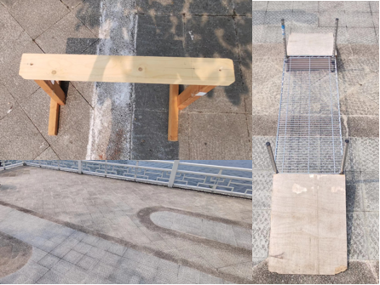

Figure . Patio 1 tasks.

* + - 1. Patio 2

Figure 2 shows the target tasks which need to be accomplished on Patio 2. The designed robot must do the following on this patio:

•Start from the green point, scanning and recognizing the shape on the stand when the robot moved to the yellow square in order to determine the direction. The robot will be placed at the edge of the green line as outlined. Before this task begins, a table tennis size ball should be carried on the robot till the second task. Then, it will be released into the basket. The robot should be programmed to move to the square at the right-hand side of the diamond where one of three shapes will be placed. After the shape has been determined, the robot will then move to the corresponding shape in the diamond. There are three situations here:

– A left arrow: The robot should move to the left-most tip of the diamond and knock out the stand with the left arrow shape.

– A straight arrow: The robot should move to the upper tip of the diamond and go over stand with the straight arrow shape.

– A right arrow: The robot should move to the lower tip of the diamond and knock out the stand with the right arrow shape. [Task 1];

• Release the tennis ball to the basket at the release point. The diameter of the basket is 25 cm and will be placed at the front of the lower rail of the fence. [Task 2];

• Transmit a message to a laptop including team name, date, day and time (24-hour clock) in radio signal at 433 MHz when the robot enters the planter area (the top edge of the planter is purple) [Task 3].

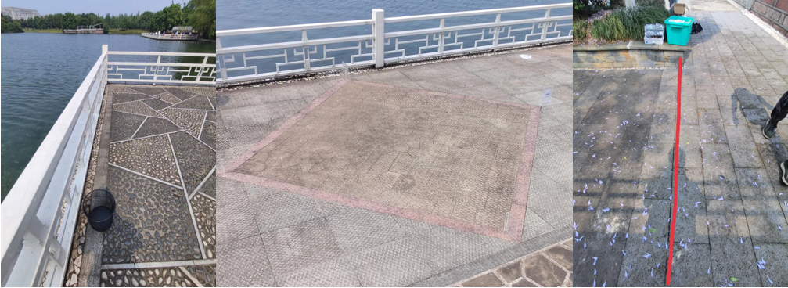

Figure . Patio 2 tasks.

* + - 1. General Rules

The robot must run a software that has been previously downloaded to the robot's microcontroller. Instructions cannot be sent to the robot in real time. The path that the robot must travel from the diamond to the basket is not governed by any regulations. Navigation along the side of the planter and pond, or along the fence, or any other method that does not infringe the basic guidelines.

A total of two beacons may be deployed on each patio to send signals for the robot to follow in order to aid it with navigation. So, for patio 1, two beacons can be utilized, or one beacon for patio 1 and one beacon for patio 2, or two beacons for patio 2.

The transition from one task to the next should be programmed (with no outside influence). All electrical systems, as well as all connections to circuit components and subsystems, must be tough and dependable. Between the battery and the remainder of the robot, a fuse and an ON/OFF switch should be installed. The fuse should be sufficiently designed such that it is not destroyed during normal robot operation but creates an open circuit if more current than predicted is pulled from the battery. Each team is asked to develop a motor driver circuit as well as the PCB that will house this circuit. The project's maximum cost is 1000 RMB.

* 1. Top-level Structure Design
     1. Sensor System

The key to the sensor system is composed of a module that includes a visual processor, ultrasonic sensor, accelerometer, and gyroscope. The main purpose of this module is to receive and process signals from the external environment, and then transmit the processed signals to the control system. In this regard, the visual processor is responsible for shape detection and line tracking. Due to the low color differentiation of the two types of tiles in the field test scene, we chose to use OpenMV4 H7 Plus to identify the boundary line between the two types of tiles to ensure stable driving of the robot for both Patio1 and Patio2. On the other hand, the ultrasonic sensor is used for distance measurement, beacon and fence recognition, and ensuring smooth and accurate movement of the robot. For this purpose, the HC-SR04 ultrasonic sensor was selected. The sensor can report the range of objects up to 13 feet away, and provide excellent non-contact range detection between 2 cm and 400 cm with an accuracy of 3mm. We installed one and two HC-SR04s on the front and left side of the robot, respectively. In addition, the module containing the accelerometer and gyroscope is equipped with MPU6050, which can control the robot's movement direction. Therefore, the sensor system module is a key component of the entire robot system, enabling it to operate effectively and efficiently.

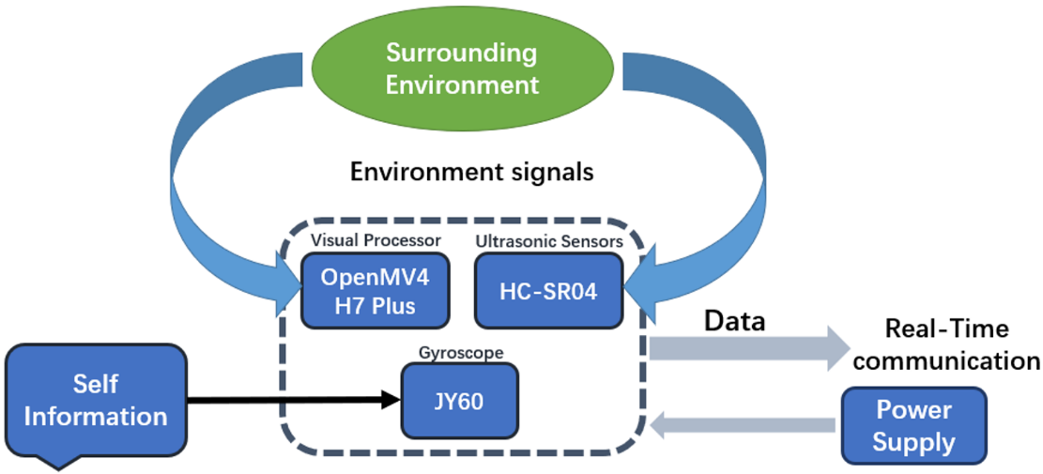

Figure . Sensor system.

* + 1. Executive Control System

The primary components of the execution control system are a microcontroller, a mechanical arm, and a motor drive circuit. The MCU receives and processes signals from the sensor system to generate control signals, which are then transmitted to the robot's components. To optimize the speed and accuracy of signal processing, we have selected NUCLEO-G474RE, which provides rich peripheral interfaces that could be connected to a variety of sensors and communication modules. The robotic arm, which comprises a position servo actuator and a 3D printed paw, is responsible for holding and releasing the ball. We have opted to use SG90 for the actuator section to control the paw's movements, so that it can rotate up to 180 degrees in both directions with a high degree of accuracy and precision. The motor drive circuit receives control signals from the MCU and drives the motor to execute commands. The circuit uses the TB6612FN motor drive chip for motor control and the MG540 encoder motor for driving the robot. Additionally, the motor drive circuit is responsible for powering the entire system.

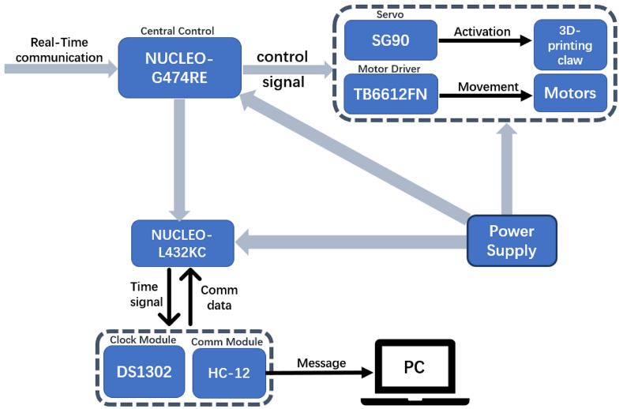

Figure . Executive control and wireless communication system.

* + - 1. Wireless Communication System

In the given scenario, the robot is responsible for transmitting a message to a designated laptop as soon as it enters the planter zone. The crucial data contained within this transmission includes the Team Name, Date, day and time, as well as the current time of day displayed in 24-hour clock format. This transmission will be accomplished using a Wavesens HC-12 wireless transceiver, which operates at 433MHz with a fixed data rate. Once the laptop acknowledges receipt of the message, the robot will continue on its pre-determined path until it reaches the endpoint indicated by a red box in the Patio 2 blueprint and a red arrow and line in the accompanying photograph. This procedure guarantees that the robot transmits updates effectively and executes assigned tasks within the specified parameters.

* 1. Implementation
     1. Sensor System Implementation: Detection for Patrol and Adjustments
        1. Visual Processor

OpenMV is an open-source, microcontroller-based machine vision platform that is designed for easy integration with a wide range of hardware and software applications [1]. As a recognition module, the OpenMV provides a comprehensive set of features for developing and prototyping embedded vision applications.

The module has an on-board image sensor that can capture images in a variety of formats, including grayscale, RGB565, and YUV422. Its powerful processor that allows for real-time image processing and analysis. The module has a set of programmable GPIO pins, which can be used for a wide range of applications, including controlling actuators and sensors.

The module comes with pre-trained models for object detection, face detection, and color recognition. It supports custom model training using TensorFlow Lite, allowing for the development of custom object detection and recognition models. Besides, the module is supported by a comprehensive set of software tools and libraries, including the OpenMV IDE, which provides a user-friendly environment for developing and testing machine vision applications. The pinout of OpenMV is shown in Figure 5.

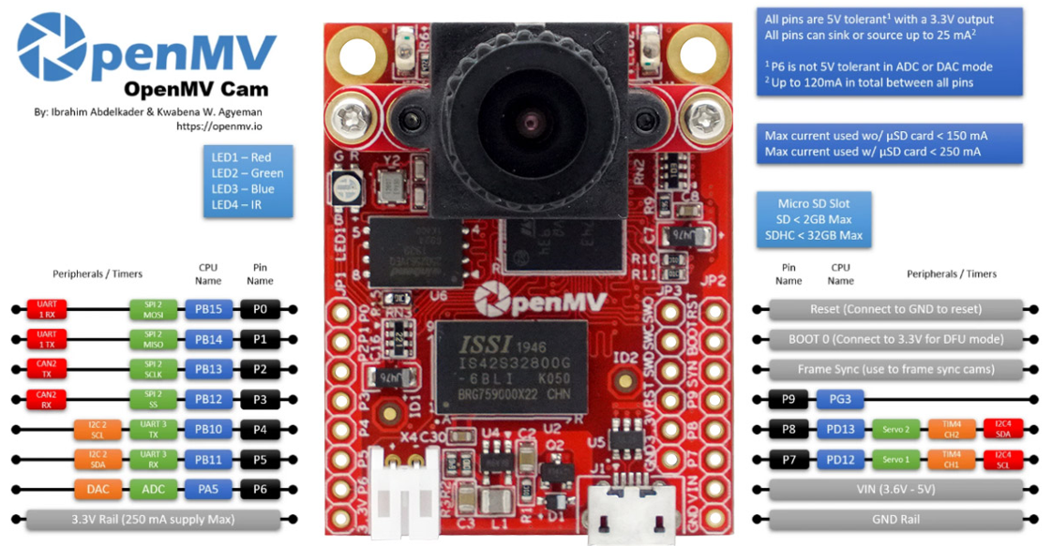

Figure . The pinout of OpenMV [1].

In this project, the NucleoG474 is the main control unit and the OpenMV is used as the vision sensor. During the patrol, the PID algorithm and image recognition are executed on the OpenMV, which transmits the data packets from the image recognition and PID algorithm to the G474 using the UART protocol, which includes the speed (corresponding duty cycle) and direction of rotation of the left and right wheels, for a total of four sets of data. The G474 uses the OpenMV data to directly control the two motors, ultimately achieving a patrol effect.

* + - 1. Ultrasonic Ranging Sensor

This project uses several ultrasonic distance sensors to measure the distance between the robot and the obstacles, intending to help the robot to decide the moment to turn and the moment to stop. We have used the HC-SR04 modules which are popular sensors used in robotics and electronic projects [2]. The HC-SR04 module was tested using a Nucleo-G474RE (a Mbed microcontroller) [3]. The installation and setup of the HC-SR04 modules are shown in Figure 6. As illustrated in the Figure, one of the three HC-SR04 modules was installed at the front of the robot and the others were installed on the same side of the robot. The front one was used to measure the distance between the robot and the obstacle ahead and the side two were used to measure the lateral distance.

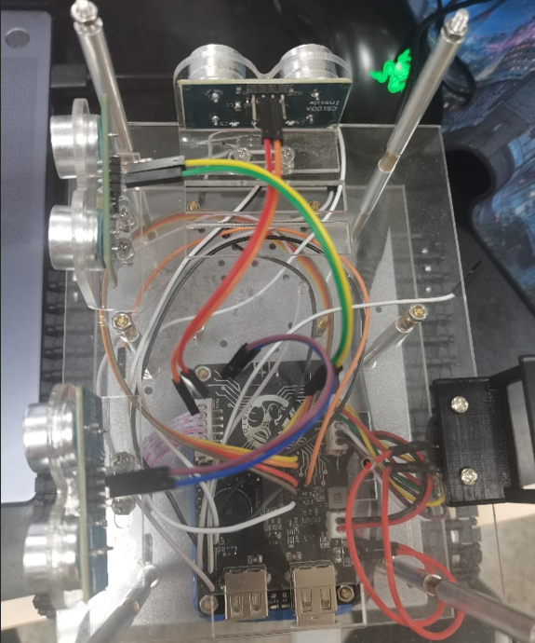

Figure . Installation and setup of the HC-SR04 modules.

The HC-SR04 pins and pin names are shown in Figure 7.

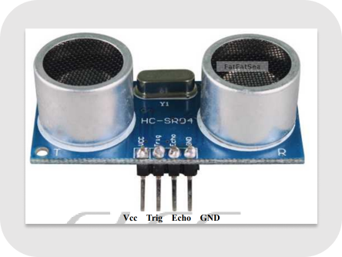

Figure . HC-SR04 pins and pin names [2].

Module debugging steps are listed as follows:

1. A high-level signal of at least 10us was input to the Trig pin.
2. The module would automatically send eight 40khz square waves and detect whether there was a signal.
3. If a signal was returned, a high level would be output through the Echo pin. The duration of the high level was the time between the ultrasonic wave being emitted and the return. The test distance D could be expressed by the following equation:

$$D=\frac{T⋅v}{2}$$

Where $T$ represents the high-level time and $v$ represents the speed of sound (340m/s).

The results of successful measurements with the HC-SR04 are shown in Figure 8.

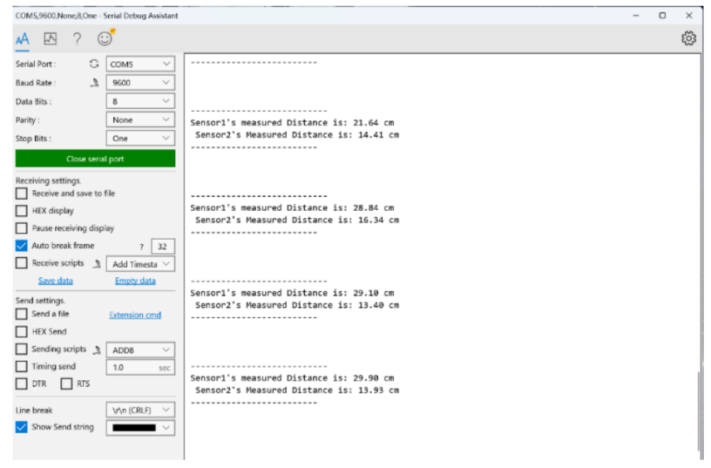

Figure . Results of successful measurements with the HC-SR04.

* + - 1. Accelerometer and Gyroscope

The JY60 module is a combined gyroscope and accelerometer sensor module that integrates a motion processing unit (MPU) 6050. This module is commonly used in robotics, UAVs, and other systems that require accurate measurement and estimation of orientation and motion.

The MPU6050 sensor is a six-axis motion processing unit that consists of a three-axis accelerometer and a three-axis gyroscope. The accelerometer measures linear acceleration, while the gyroscope measures angular velocity. The JY60 module integrates these sensors with a built-in attitude estimation algorithm that combines the data from the accelerometer and gyroscope to estimate the orientation and motion of the object in real-time.

The MPU6050 is used in our robot when the robot needs to turn at a specified angle. In patio 1, for example, the robot needs to turn 90° to perform task 2 on the bridge when it finishes the line patrol. The application of MPU6050 is not just restricted to quarter turn. With the help of MPU6050, our robot can turn at any specified angle theoretically, which makes our robot more flexible and adapt different scenes.

There are two difficulties in implementing this part: the attitude determination and control algorithm of the MPU6050, and the communication between this module and the MCU.

The MPU6050 contains both an accelerometer and a gyroscope which can be used to measure the direction and motion of the device. However, the angle cannot be obtained directly, and we need to use the data gain from its 3-axis gyroscope and 3-axis accelerometer to calculate the angle. This is where we need the Attitude Determination and Control (ADC) algorithm, which takes the raw data from the sensors and processes it to calculate the device's orientation and acceleration. This data is then used by the control system to adjust the motion of the device to maintain stability.

JY-60 is a common Inertial Measurement Unit (IMU) that integrates the MPU6050 chip and Kalman filter. Kalman filter is one of the most used ADC algorithms. JY-60 communicates with a microcontroller through a standard UART interface and transmit the angles directly to the microcontroller.

Another difficult part is the Data Unpacking between JY60 and MCU. JY60 uses WT61 protocol to transmit its data. The WT61 protocol is a serial communication protocol used for transmitting data from inertial measurement units (IMUs). The WT61 refers to a type of IMU module that outputs sensor data such as accelerometers, gyroscopes, and magnetometers using the WT61 protocol. The protocol uses UART serial communication to transfer data. The data format is shown in Table 1. The start byte and end byte are both fixed values of 0x55 and 0xAA, respectively. The flag byte of 0x53 indicates that the data packet is a sensor data packet. The data length varies depending on the specific implementation and the data field contains the sensor data. The checksum field is calculated by summing all bytes except the start and end bytes, taking the one's complement, and adding 1.

Table . The data format using UART serial communication.

|  |  |  |  |  |  |
| --- | --- | --- | --- | --- | --- |
| Start Byte | Flag | Data Length | Data | Checksum | End Byte |
| 0x55 | 0x53 | 0xXX | Data | Check | 0xAA |

Corresponding code should be written to perform data unpacking on the data gain from the JY60 to make the data programmable for latter experiment.

* + 1. Executive Control System Implementation: Robot Control and Operation
       1. MCU

The Nucleo-G474RE module is a development board based on the STM32G474RE microcontroller, which is a member of the STM32G4 series of 32-bit ARM Cortex-M4 microcontrollers [3]. As a main controller module, it provides a comprehensive set of features for developing and prototyping embedded applications. It also has a rich set of peripherals, including multiple UART, SPI, and I2C interfaces, USB, CAN, and ADC.

Nucleo-G474RE pin names and pinouts are shown in Figure 9.

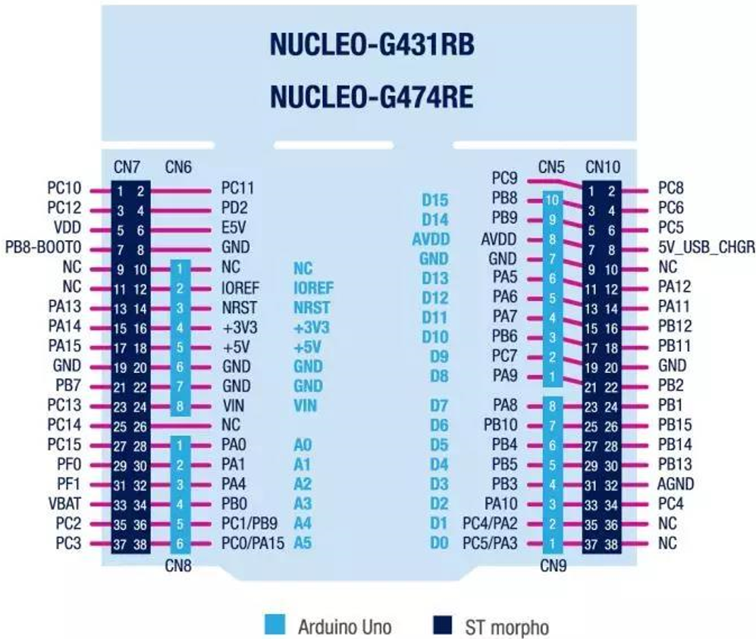

Figure . Nucleo-G474RE pin names and pinouts.

* + - 1. Power Regulator Circuit

The power supply of all hardware circuits in this design is provided by a 12V rechargeable lithium battery pack. However, some of the other modules require a 5V or 3V3 power supply. Our team have compared two plans for the power regulated circuit with each other:

Plan A: Use TI’s LM2596S DC-DC regulator to convert 12V to 5V, and then obtain 3.3V through LDO-LP2992. LM2596S is a monolithic IC that provides all the active functions for a step-down (buck) switching regulator, capable of driving a 3A load with excellent line and load regulation. However, the LM2596S is an obsolete chip that not only has a low level of integration and a large footprint but also requires relatively more complex peripheral circuitry. Also, LP2992 only has a maximum output current of 250mA, which may not fully fulfil the power requirement of the system.

Plan B: Use Silergy’s synchronous step-down DC-DC regulator SY8368 to convert 12V to 5V, and then obtain 3V3 through LDO-ME6211. SY8368 could provide a highly stable and efficient 5V output, while its integrated multiple battery protection functions could protect the system. It is a new chip with a high level of integration and a tiny footprint, significantly reducing the complexity of the peripheral circuits. The ME6211 performs with high PSRR, low noise, low ripple, and low dropout 3v3 output power supply for digital voltage. It can also provide an accurate reference voltage for ADC.

Finally, our team decided to use plan B, since it is more efficient and less complicated, with less noise and higher stability.

The schematic is shown in Figure 10. As shown in Figure 10, a fuse and a switch are also considered in the design of switching power supplies. The overall power supply is 3A and two 1A Fuses are specially designed for protecting OpenMV and G474. It should be noted that the switch and power cable has been specially selected to carry 3A current.

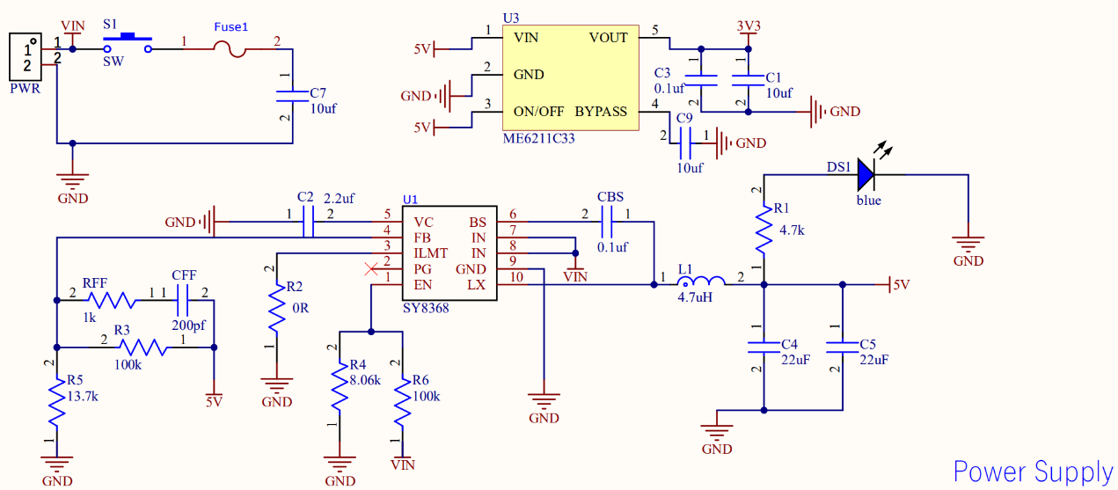

Figure 10. The power regulated circuit.

The parameters of the devices in Figure 10 are calculated as follows:

$C_{1}$

$C_{in}$ is the $C_{1}$ in Figure 10. $fsw=800kHz, I_{out-max}=3A$. Assume that $V_{in-ripple}=400mV$, $ESR_{max}=100mΩ$.

$$∵V_{in-ripple}=\frac{0.25I_{out-max}}{C_{in}×fsw}+I_{out-max}×ESR_{max}$$

$$∴C_{in}=9.375μF≈10μF$$

$V_{out}$

$$R_{5}=R_{3}×\frac{V_{ref}}{V_{out}-V_{ref}}⇒V_{out}=V_{ref}×(\frac{R_{3}}{R_{5}}+1)$$

$$∵V_{ref}=0.6V, V_{out}=5V, ∴set R_{3}=100kΩ, R_{5}=13.7kΩ$$

The value of $V_{out}$ in reality, is equal to 4.98V.

1. EN pin

$$V_{start}=3.6×3=10.8V, V_{stop}=3.3×3=9.9V$$

$$V_{ENH}=0.8V, V_{ENL}=0.4V$$

$$∵\frac{V_{in}-V_{EN}}{R_{6}}=\frac{V_{EN}}{R_{4}}⇒\frac{V_{start}-V_{ENH}}{R_{6}}=\frac{V_{ENH}}{R_{4}}, \frac{V_{stop}-V_{ENL}}{R_{6}}=\frac{V_{ENL}}{R_{4}}$$

$$∴R_{6}=100kΩ, R_{4}=8.06kΩ⇒V_{start}=10.8V, V_{stop}=10.4V$$

$L_{1}$

$$L_{1}=\frac{V_{out-max}×\left(V_{in-max}-V_{out}\right)}{V_{in-max}×r×I_{out}×fsw}$$

$$V_{out-max}=4.2×3, set r=0.4\left(ripple I\right)$$

$$∴L_{1}=3.14μH, choose L_{1}=4.7μH$$

$$I_{L-RMS}=\sqrt{I_{out-max}^{2}+\frac{1}{12}×{\left(\frac{V_{out}×\left(V_{in-max}-V_{out}\right)}{V_{in-max}×L_{1}×fsw×0.8}\right)}^{2}}=3.014A, set I_{out-max}>3.5A$$

$$I_{L-CPK}=I_{out}+\frac{V_{out}×(V_{in-max}-V_{out})}{1.6×V_{in-max}×L_{1}×fsw}=3.501A$$

$C_{out}$

$$C_{out}>2×\frac{ΔI_{out}}{fsw×ΔV_{out}}$$

Assume that: $ΔI_{out}=75\%I=2.25A, ΔV_{out}=5\%V_{out}=0.25V,$

$$∴C_{out}>22.5μF$$

At the same time: $C_{out}>\frac{1}{8fsw}×\frac{1}{\frac{V_{out-ripple}}{I_{LPK}-I_{RMS}}}, set V_{out-ripple}=1\%V_{out}=50mV$

$$∴C_{out}>1.521μF$$

Finally, since the available inductance is greater than the design value, two $22μF$ 25V 0805 ceramic capacitors are connected in parallel as the $C_{out}$.

Additionally, a blue LED is also present at the output. If the power is on, the blue LED will be turned on.

* + - 1. Battery Monitoring Circuit

Overcharging or over-discharging can both compromise the life span of a lithium battery pack. There is an optimum safe operating voltage range, specifically between 10.5 V and 12.6 V. Additionally, it is useful to receive real-time information about the battery level since whether the robot has enough power could be checked.

Therefore, a battery monitoring circuit was designed, which includes a potential divider and a buzzer alarmer. The core of this circuit is a potential divider which can divide 12V supply to be 3v3 logic compatible so that the signal could be read by the onboard ADC and processed by the MCU. The buzzer is controlled by a triode SS8050 [4]. When a HIGH-level signal is given to the SS8050 by the controller, the triode will become conductive, pulling down the buzzer to make it alarm.

Before making the final decision, 3 plans have been compared with each other:

Plan A: A coulometer could be used. The coulometer can provide power information with the highest accuracy. However, this coulometer may need to work with a current sense chip to measure the power, resulting in a higher cost as well as more complexity in programming.

Plan B: Monitoring the output voltage. Since the battery power can be converted into a corresponding electric potential, its voltage could be monitored to get rough information. This method is easy, but the accuracy is relatively low.

Plan C: Impedance tracking method: Calculating the impedance value of the object by applying a variable frequency signal to the measurement object and monitoring the amplitude and phase changes of the signal passing through the object.

Finally, Plan B was chosen since this method could be easily achieved in both hardware and software. Additionally, an ADC could be used, which our team is more familiar with. The relatively low accuracy could be corrected by programming.

The battery monitoring circuit is shown in Figure 11. KPEG242 is a buffer. The final experiment result showed that when the safe operating voltage range was exceeded, the buzzer alarmed and the power level will be displayed on an OLED screen.

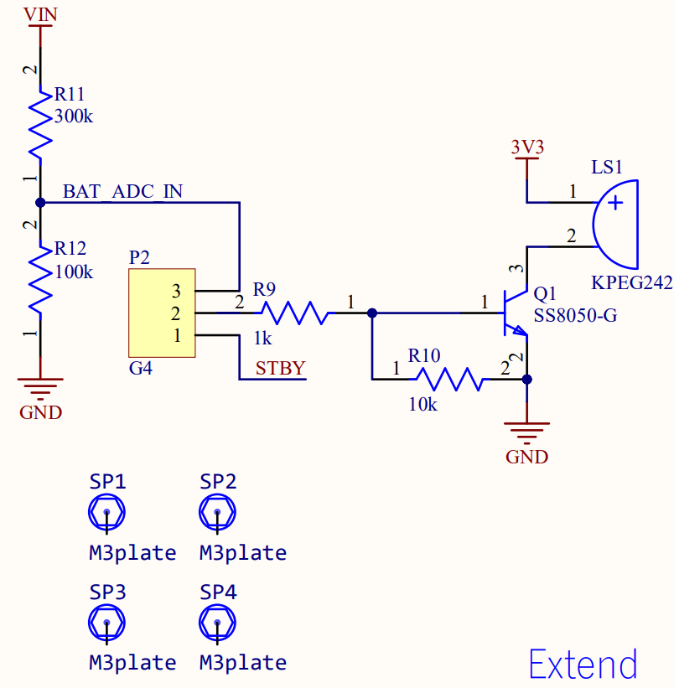

Figure 11. The battery monitoring circuit.

* + - 1. Motor Drive Circuit

A motor drive circuit has been designed to drive the motors. There are mainly two reasons why the robot needs such a motor drive circuit.

Firstly, it is convenient to control the speed of the motor. As for ordinary motors, they could turn once they are powered, but when it comes to controlling the speed that they turn, how the motor speed could be controlled by controlling the voltage depends on this motor drive circuit.

Secondly, the motor drive circuit could contribute to meeting the power requirements of the motors. In order to meet the rated power requirements of the motors, the drive circuit could be added to make adjustments.

To implement the motor drive circuit, a proper motor drive circuit should be chosen. There are two types of motor drive chip which are used to control low power DC motors and stepper motors and commonly seen in the market, L298N and TB6612FNG:

L298N [5]: This chip supports 7V to 35V operating voltage. The output current can reach 2A. However, L298N has relatively low efficiency and needs a heatsink to prevent it from overheating. Additionally, it requires a current-continuity diode to build the peripheral circuit.

TB6612FNG [6]: This chip can operate motors from 2.5 to 13.5V on the motor voltage and boasts up to 95% efficiency1. It also has a low current standby mode. It has two digital inputs per H-bridge (one for each half of the bridge) as well as a PWM control frequency that reaches up to 100kHZ so you can control motor speed. It runs at 2.7V-5V logic and is good for motor voltages from 4.5V up to 13.5V.

Our final decision was TB6612FNG. Since, compared with L298N, TB6612FNG has higher efficiency and smaller size.

Then, the schematic was designed according to the datasheet and the schematic is shown in Figure 12.

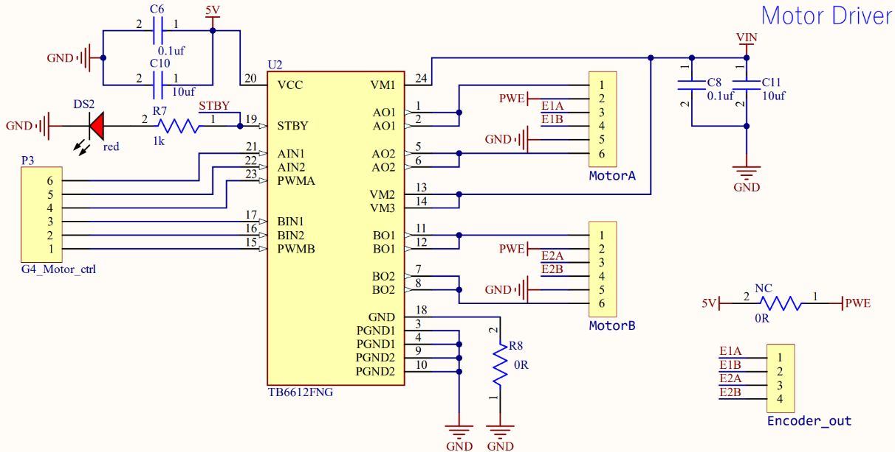

Figure 12. Motor drive circuit schematic.

As shown in Figure 12, two brushed DC motors are driven. Additionally, decoupling capacitors are added to reduce noise and voltage spikes generated by the motors. The decoupling capacitors also help to stabilize the power supply voltage by providing a low-impedance path for high-frequency noise. As for STBY pin, red LED is connected to the pin. The red LED functions as an indicator: If the STBY is pulled up, the red LED will be turned on, indicating the motors are ready to operate. A NC resistor has also been designed for commissioning hall encoders.

* + - 1. Motors

The MG513 is a DC geared motor with a Hall encoder, which provides precise and accurate control of the motor's speed and position [7]. The motor has a high torque output and smooth operation, which makes it suitable for applications that require high power output. Equipped with a Hall encoder, it provides precise feedback on the motor's speed and position.

The Hall encoder is a type of position sensor that provides precise and accurate feedback on the motor's speed and position. The encoder works by detecting changes in the magnetic field produced by the motor's magnets as they pass over the Hall sensors. This information is then used to calculate the motor's speed and position.

The MG513 motor can be controlled using a variety of motor control techniques, including PWM (Pulse Width Modulation) and PID (Proportional-Integral-Derivative) control. These control techniques allow for precise control of the motor's speed and position, which is essential for applications that require high precision and accuracy. In this project, we used PWM to control the motors.

When trying to get a robot to move in a straight line, we often think that we just need to make sure that the duty cycles of both motors are the same. This idea has been proven wrong in practice.

Two motors of the same model will have different speeds during operation due to a number of factors. These factors include:

1. Different supply voltages: If two motors are connected to different supplies they may receive different voltages, which may result in different speeds.

2. Different loads: If two motors are under different loads, they may also have different speeds. For example, if one motor is installed in a light load application, it may run faster, while the other motor may have to carry a heavy load and run slower.

3. Mechanical faults: If a motor has mechanical faults or wears out, its speed may be reduced.

4. Magnetic field deviations: Two motors of the same model may have slight manufacturing differences, such as magnetic field deviations, which may result in different speeds.

* + - 1. PCB

There are many advantages to integrating devices into the PCB board: 1. Simplify the circuit 2. Contribute to the stability of the circuit, reduce the influence of electromagnetic interference and temperature drift on the circuit 3. Insulate and separate the conductive parts (lines) in the circuit and components) to avoid faults such as short circuits. Therefore, our team has decided suitable footprint and packaging and made manual routing, following the design rules for PCBs.

Altium Designer is a professional PCB design software, which integrates various processes of PCB design, and it is a high-performance and easy-to-use tool. Our team used Altium Designer for PCB layout design.

The PCB wiring is shown in Figure 13.

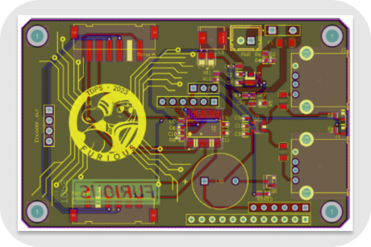

Figure 13. The PCB board wiring.

The front and back of the PCB are shown in Figure 14.

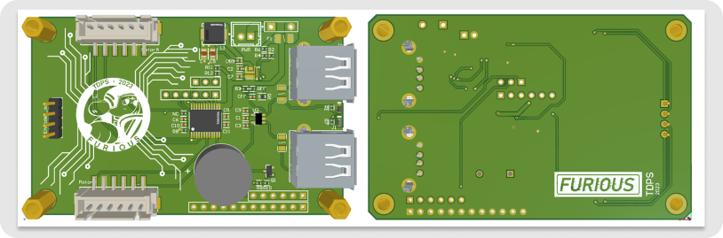

Figure 14. The front and back of the PCB.

Additionally, as for the clock, MPU, and wireless communication modules, to achieve better and more stable mounting of them, our team has designed an additional expansion board serving as a connector.

The extension board wiring is shown in Figure 15.

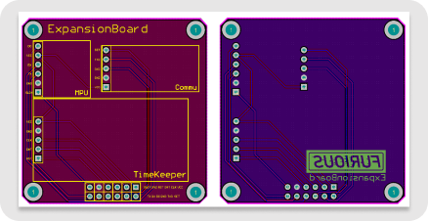

Figure 15. The extension board wiring.

The front and back of the extension board is shown in Figure 16.

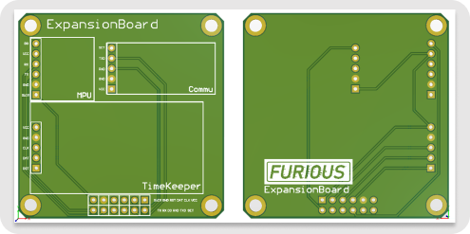

Figure 16. The front and back of the extension board.

The front and back real shots of PCB and extension board are shown in Figure 17.

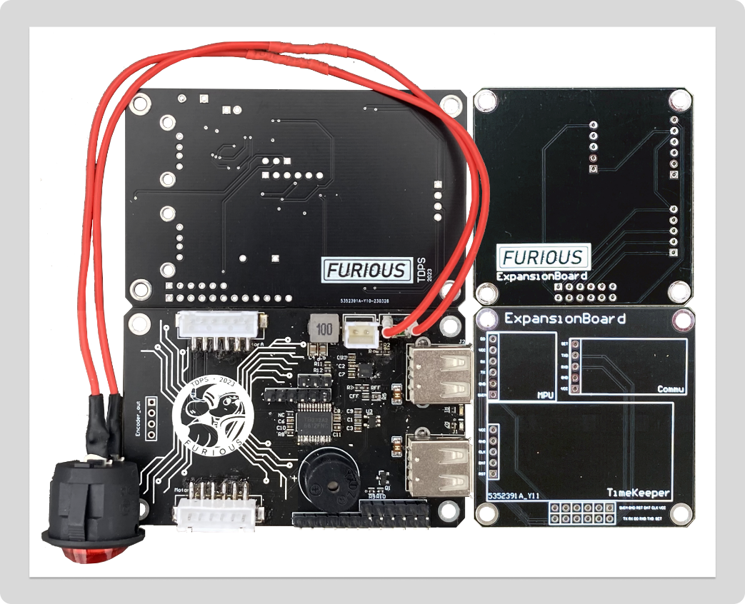

Figure . The front and back real shots of PCB and extension board.

After experimental testing, the PCBs designed by our group can work normally.

* + - 1. Mechanical Arm

The mechanical arm system aims at completing task 2 of patio 2, which requires the robot to hold a table tennis ball at the beginning of patio 2 and place the ball in a basket after patrolling. Our team has proposed a solution that a 3D-printed claw to be installed on the trolley at enough height. After detecting the basket, a SG90 servo was used to open the claw and release the ball. The 3D-printed claw is shown in.

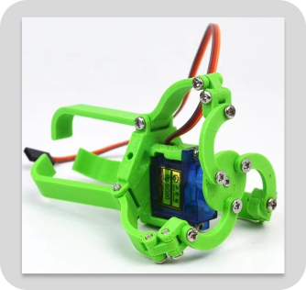

Figure . 3D-printed claw.

SG90 is a small-sized, low-cost servo motor that is commonly used in hobbyist and DIY projects. It is designed to be lightweight and compact, making it ideal for small-scale applications that require precise control of movement.

The SG90 servo motor operates using pulse-width modulation (PWM) signals from a microcontroller or other control board. It has a 3-wire interface that includes a power supply, ground, and signal line. The signal line receives PWM signals that dictate the position of the motor shaft, while the power supply and ground lines provide power to the motor.

The SG90 servo motor has a 180-degree rotation range and can operate at a speed of up to 60 degrees per second. It also has a torque output of up to 1.8 kg/cm, making it capable of lifting small loads or controlling the movement of small mechanical components.

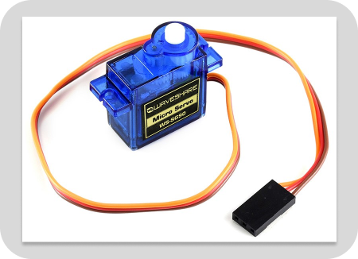

Figure . SG90 servo.

Raising the height of the arm was to fix a PVC pipe at a 45-degree angle to the surface of the robot on the third layer. The fixing method was to cut a triangular plate using laser cutting and then fix the triangular plate to the third layer board through triangular brackets. The PVC pipe was fixed to the triangular plate using screws and nuts. The lead to the servo was connected to the MCU by passing through the PVC pipe. Additionally, we have also designed a 3D printed connector which is shown in Figure 20. The connector was fixed to a PVC pipe while holding the claw in a constant position.

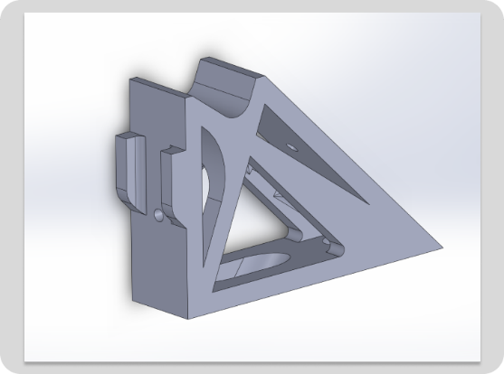

Figure . 3D printed connector.

In addition, the OpenMV was also loaded onto the mechanical arm via a slider which is shown in Figure 21. The position of this slider on the mechanical arm could be adjusted.

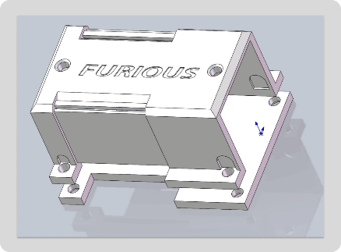 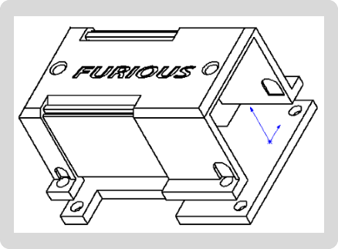

Figure . Slider design drawing.

The overall mechanical arm is shown in Figure 22.

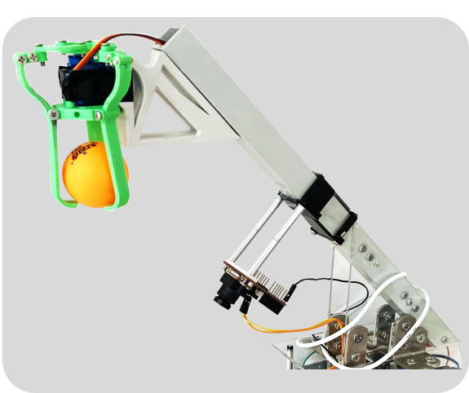

Figure . The overall mechanical arm.

* + 1. Wireless Communication System Implementation: Message Delivery

During patio 2-task 3, our robotic unit is programmed to stop moving when it enters the designated planter region. At this point, it is tasked with transmitting a comprehensive message directly to a linked laptop. The message includes critical elements such as the team name, current date, day of the week, and timestamp of this operation. We will use a Wavesens HC-12 wireless transceiver operating at 433MHz to facilitate the transmission of this critical data and ensure fast and seamless transmission without latency or interruptions. The robot is programmed to resume its journey to the end of its designated route when the laptop successfully receives the signal.

* + - 1. HC-12

The HC-12 wireless serial communication module is a revolutionary addition to wireless data transmission technology. It operates within the 433.4-473.0MHz band and can transmit with a robust power of up to 100mW. With 400 KHz increments and support for up to 100 channels, this module adapts easily to different applications. The module's receiving sensitivity reaching -117dBm ensures errorless communication up to a distance of one kilometer in open areas. This module effortlessly integrates into application systems due to its stamp hole design, compact size, and patch welding support. It offers two distinct antenna options to its users. The first is an ANT1 PCB antenna base for an external 433M antenna, while the second is an ANT2 junction for spring antenna welding.

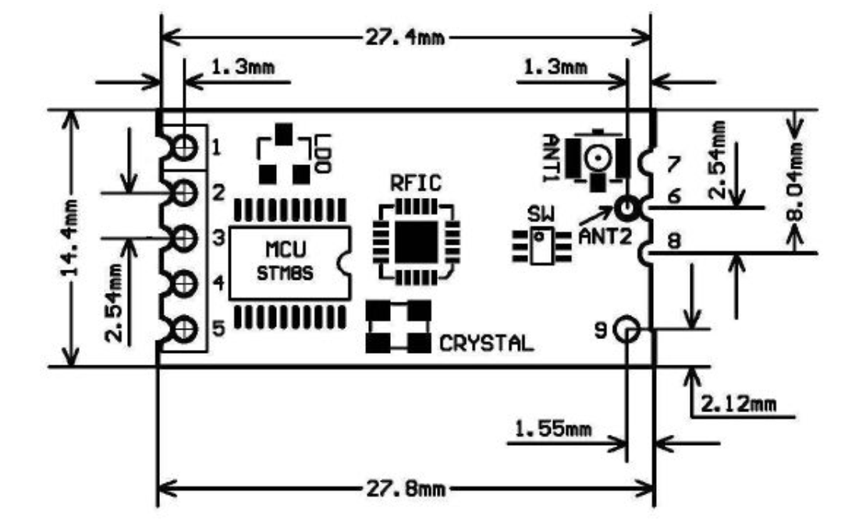 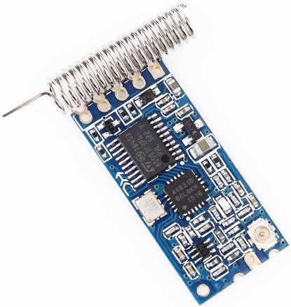

* + - 1. UART

UART, an acronym for Universal Asynchronous Receiver/Transmitter, is a widely used hardware device or protocol that manages asynchronous serial communication between computers, microcontrollers, and other peripheral devices. One of the main advantages of UART is its simplicity and ease of use. It only requires two wires for communication: one for transmitting data (TX) and another for receiving data (RX). This feature makes UART ideal for basic serial communications over relatively long distances. Unlike SPI and I2C, UART does not require a clock signal for data synchronization. Instead, data is transferred asynchronously. This means the transmitter and receiver merely need to agree on the data rate, also known as the baud rate, prior to communication. The data structure in UART communication is quite straightforward. It starts with a start bit, followed by data bits (usually 8), optionally a parity bit for error checking, and finally a stop bit.

In order to use the UART, we need to figure out how to use it, the specific steps are summarised below:

1. Configuration: The first step in using UART is to configure the settings for the communication. Both devices involved in the communication must agree on these settings, which typically include the baud rate (speed of communication), data bits (commonly 8), stop bits, and parity (for error detection).

2. Data Transmission: Data transmission using UART follows a specific structure called a data frame. Each frame starts with a start bit, followed by the data byte, then an optional parity bit, and finally one or more stop bits. When the UART transmitter sends data, it converts the data from parallel to serial form, then sends it bit by bit.

3. Data Reception: On the receiving side, the UART receiver converts the received serial data back into parallel form. It checks for start and stop bits to determine the beginning and end of the data frame. If parity is used, the receiver also checks the parity bit for possible transmission errors.

4. Error Checking: When the parity bit is used, any error during the transmission can be detected. If an error is found, the receiving device must have an error-handling mechanism in place, typically requesting the transmitting device to resend the data.

5. Data Processing: Once data is received and any errors are addressed, the data can be processed as needed for the given application.

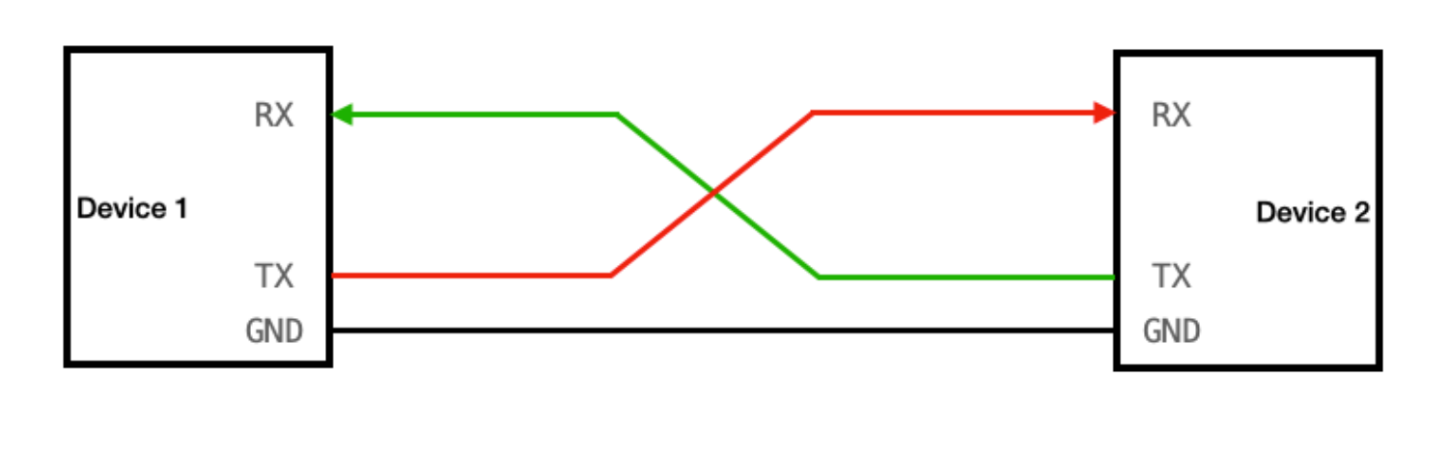

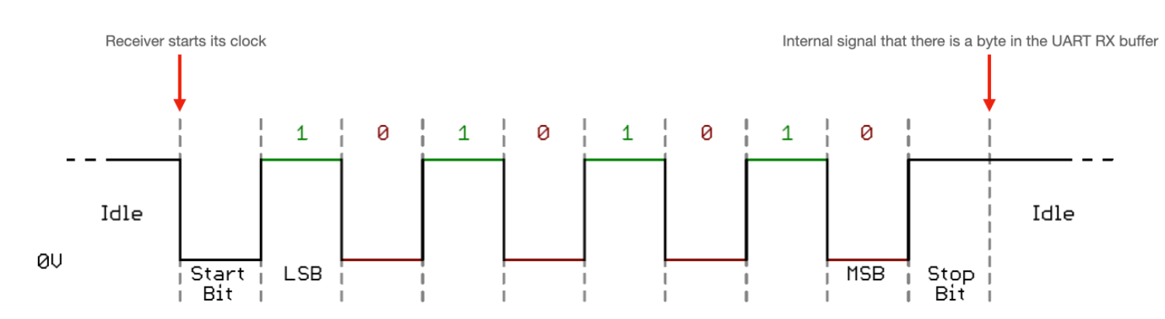

The HC-12 module applies UART as a crucial part of its data handling process. It uses UART for both initial configuration and ongoing communication with a connected device. By employing UART, the HC-12 receives data in a format that's ideal for wireless transmission. The module interprets incoming UART data, wirelessly transmits it using its built-in RF transceiver, and converts received RF signals back into UART data for the connected device. This underlines how central the UART protocol is to the HC-12's functionality in a wireless communication setup.

* + - 1. Wireless data transmission

The working principle of wireless data transmission using the HC-12 module involves two main components: the transmitter and the receiver. For the transmitter, the HC-12 module encodes the serial data and modulates it using FSK modulation, which involves shifting the carrier frequency between two predefined frequencies to represent 0s and 1s in the data stream. Then, the encoded and modulated data is then transmitted wirelessly using the HC-12 module's built-in antenna. The module uses the 433MHz frequency band, and the transmitted data can reach a range of several hundred meters, depending on the environment and obstacles. For the receiver, it received the transmitted data through its antenna, which operates on the same frequency as the transmitter module. The received data is decoded and demodulated by the HC-12 module, converting it back into the original serial format. Then, the decoded data is then sent to the receiving device through UART. The receiving device can process the data according to its intended application.

* + - 1. DS1302 Clock Module

The DS1302 is a trickle-charge timekeeping chip from Maxim Integrated that contains a real-time clock/calendar and 31 bytes of static RAM. It communicates with a microprocessor via a simple serial interface. The real-time clock provides seconds, minutes, hours, days, dates, months, and year information. The end-of-the-month date is automatically adjusted for months with fewer than 31 days, including corrections for leap years. The clock operates in either the 24-hour or 12-hour format with an AM/PM indicator. The DS1302 has a built-in power-sense circuit that detects power failures and automatically switches to the backup supply. Timekeeping operation continues while the part operates from the backup supply. The DS1302 is designed to operate on very low power and retain data and clock information on less than 1μW. The DS1302 is particularly useful in applications where low power consumption is critical, such as battery-backed devices. In our robot car, we connect the DS1302 chip to the L432KC microprocessor. To set up this device, the following steps are conducted:

Software Configuration:

a. Import or configure the necessary libraries for communication with the L432KC.

b. Configure the selected GPIO pins as per the L432KC specifications and assign the correct pin numbers.

c. Implement the software driver for the communication protocol with the DS1302 and we choose SPI as our protocol.

Initialization and Communication:

a. In the main program, initialize the selected GPIO pins, set their direction, and configure other necessary parameters.

b. Initialize the DS1302 module by sending control commands and data to configure its operating mode and time format.

c. Read or update the time and date by sending commands using the communication protocol with the DS1302.

d. Use the relevant features and libraries of the L432KC to perform desired operations based on the time information provided by the DS1302.

To apply the DS1302 module to the L432KC microcontroller, connect the VCC and GND pins of the DS1302 to the 3.3V power pin and ground, respectively. Then, connect the DAT, CLK, and RST pins to three separate configurable GPIO pins of the L432KC microcontroller.

* + 1. Peripherals
       1. OLED

In this project, the use of OLED was not directly related to the tasks and was only used to output the name and slogan of our team.

An OLED (organic light-emitting diode) is a diode which contains organic compounds that emit light when an electric current passes through them. OLED displays are known for their high contrast ratio, wide viewing angles and low energy consumption. In recent years they have become increasingly popular and are commonly used in smartphones, TVs and other electronic devices. The technology allows for thinner screens and sharper images than conventional LCDs.

A liquid crystal display (LCD) is a flat screen or other electronically moderated optical devices that uses the light modulation characteristics of liquid crystals in combination with a polariser. The reason for not using LCDs here is that they do not display well and displaying clear text is more complex.

The texts “WE ARE FURIOUS” and our team name “FURIOUS” were displayed successfully using an OLED, which is shown in Figure 23.

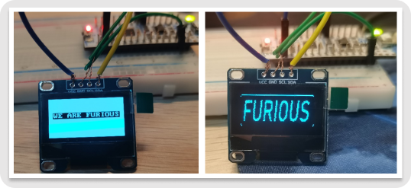

Figure . Displaying texts successfully using an OLED.

* + 1. Robot Mechanical Structure

Having implemented the functions of the different subsystems, we needed to combine the different components to form a fully functional robot, which involved designing a rational overall mechanical structure.

The large trolley chassis we have chosen for our robot is relatively small and at the same time we need to mount different kinds of sensors and mechanics on the chassis. Taking into account the limited space and the coordination of the robot, we designed different layers to mount the different parts of the subsystem.

After the layout of each layer has been determined, the structure of each layer was drawn on AutoLaser. AutoLaser software refers to the computer programs and algorithms that operate the laser distance measurement system. It controls the hardware components such as the laser transmitter and timer, calculates the distance based on the time of flight of the laser pulse and provides the user with the results of the measurement and any other information. After the layout was finished, the laptop was connected to the laser cutter and the acrylic panels were cut into the designed structure and layout.

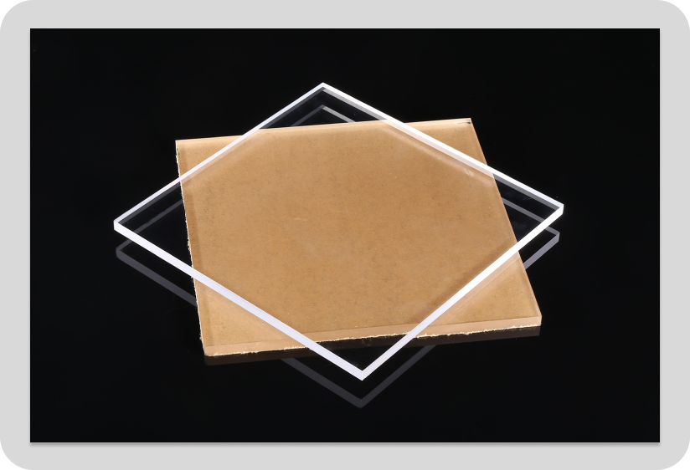

Figure . Acrylic panel.

The chassis of the robot and a front support frame is shown in Figure 25. The battery was fixed in the chassis of the robot rather than in one of the layers of the robot. This kind of fixation has two advantages: it can free up valuable space and it can lower the center of gravity of our robot, which is helpful for task2 in patio1 when the robot needs to cross the bridge. Additionally, probably due to the small chassis and the high body, the robot tends to roll over when going off the bridge. Therefore, we have added a front support frame to the base. As shown in Figure 25, a triangular structure made of wooden panels was also mounted on the front support frame which is used for knocking out the stands.

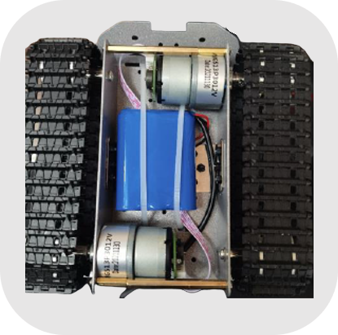 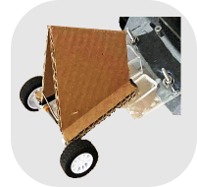

Figure . Chassis of the robot.

Apart from the base of the robot, we have designed a total of three layers of structure. From the bottom to the top, the first, the second and the third layers.

On the first layer, the motor driver PCB, and the extension PCB used to connect the angular velocity and accelerometer modules, wireless communication modules and clock modules (including these three modules) were placed. The schematic diagram of the structure of the first layer is shown in Figure 26.

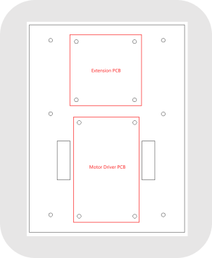

Figure . The schematic diagram of the structure of the first layer.

On the second layer, the three ultrasonic ranging sensors, the MCU, the OLED as well as the switch were placed. We have also designed a frame to hold the OLED and the switch, which is shown in Figure 27.

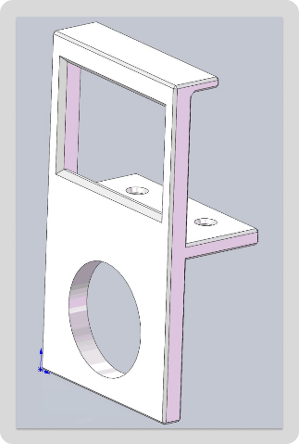 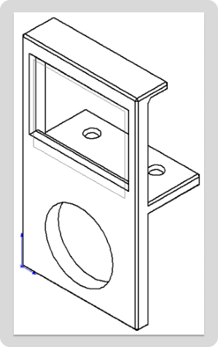

Figure . The frame to hold the OLED and the switch.

The schematic diagram of the structure of the second layer is shown in Figure 28. One of the ultrasonic waves was mounted directly in front of the body and the remaining two were mounted on the right side facing the forward direction.

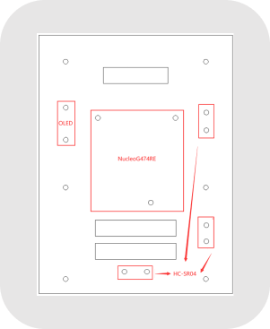

Figure . The schematic diagram of the structure of the second layer.

On the third layer, the PVC tube and the mechanical claw were installed. The OpenMV was fixed on the PVC tube. This kind of fixation makes it much more convenient for us to adjust the position and height of OpenMV. It also facilitated the collection of more information on the road surface by OpenMV. The schematic diagram of the structure of the third layer is shown in Figure 29.

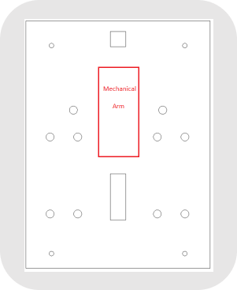

Figure . The schematic diagram of the structure of the third layer.

The triangular plate for connecting and fixing PVC pipes to the third layer is shown in Figure 30.

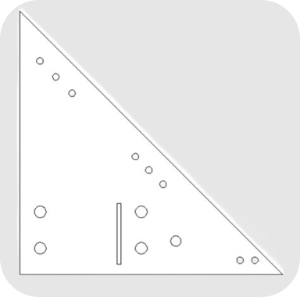

Figure . Triangular plate for connecting and fixing PVC pipes.

The final assembled robot is shown in Figure 31.

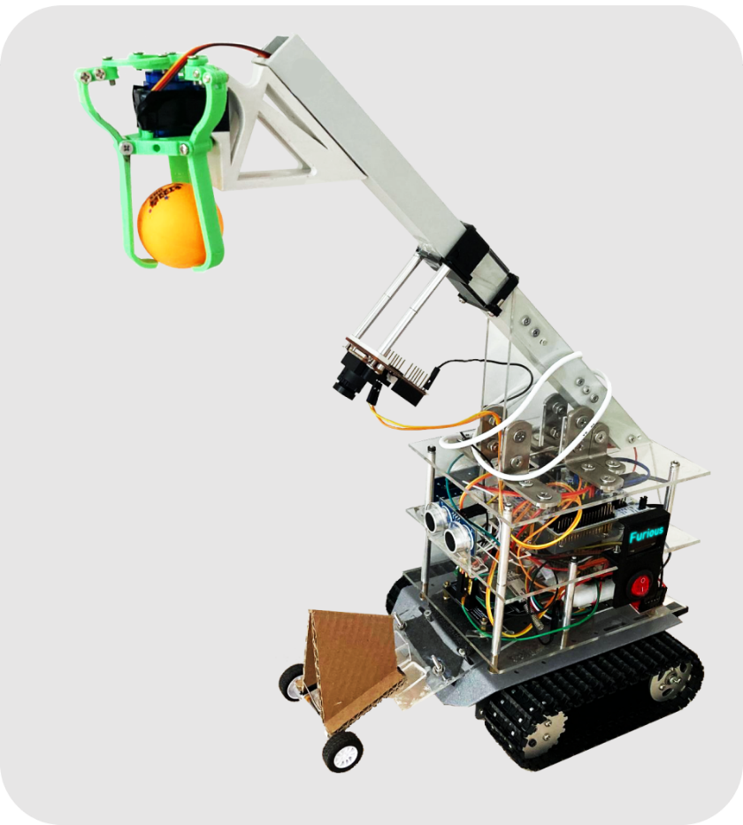

Figure . The final assembled robot.

* + 1. System Integration
       1. Patio 1

The patio 1 scene layout and partial action track is shown in Figure 32. The patio 1 task can be divided into three general phases. As for the first phase, the robot will start from the starting point (green) and follow the trail to the bridge (blue) by identifying the coloured tiles. As for the second phase, the robot detects the obstacles (yellow) to its right, makes a turn and then goes up and down the bridge. As for the third phase, after coming down from the bridge, the robot recognises the coloured tiles (blue) and follows the path to the gate (purple). Once the gate has been detected, the robot will stop automatically after a short period of time.

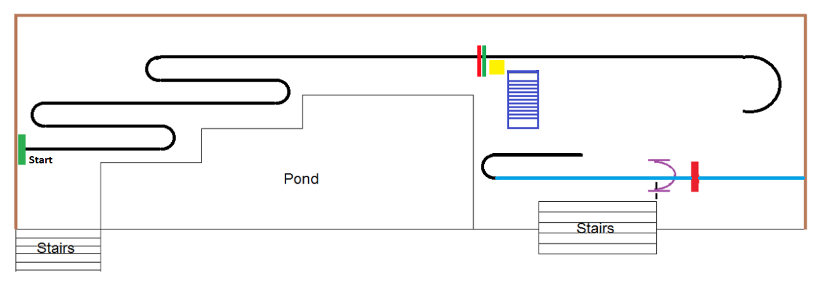

Figure . Patio 1 scene layout and partial action track.

The patio 1 flow diagram is shown in Figure 40, which corresponds to the control logic of the MCU code.

The first loop shown in the flowchart corresponds to the first stage of patio 1: OpenMV continuously identifies the coloured tiles and sends the processed information to the MCU, which in turn sends control signals to the motors for line tracking. During this loop, the two ultrasonic sensors on the right side of the robot are also constantly checking the distance to the obstacle. When the distance detected by both ultrasonic sensors is less than 20 cm at the same time, i.e. when the robot finishes the first phase of patrolling and comes to the yellow obstacle shown in Figure 32, the robot exits the first loop.

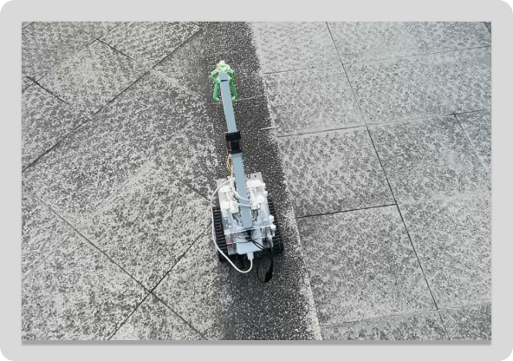 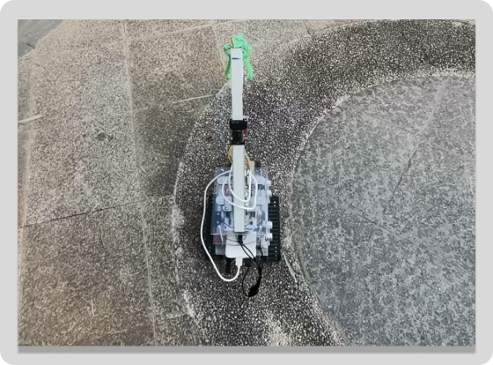

Figure . Line tracking in phase 1 of patio 1.

When the robot detects the obstacle, the robot will again travel straight ahead for 0.7 seconds to a position roughly on the horizontal median of the bridge. Then the robot itself turns 90 degrees to the right in place using the angular accelerometer and gyroscope.

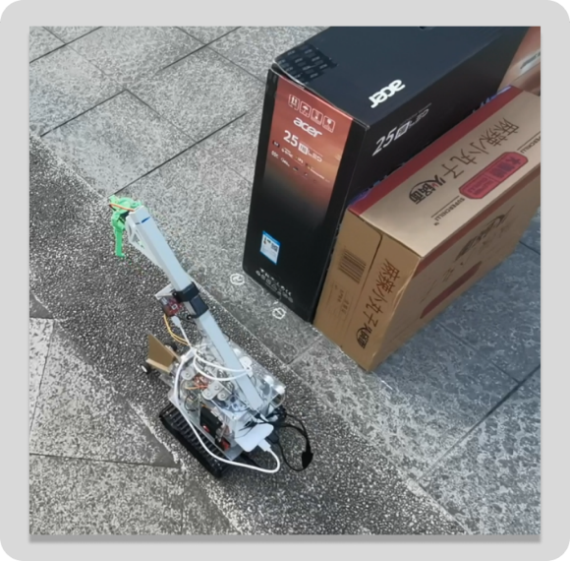 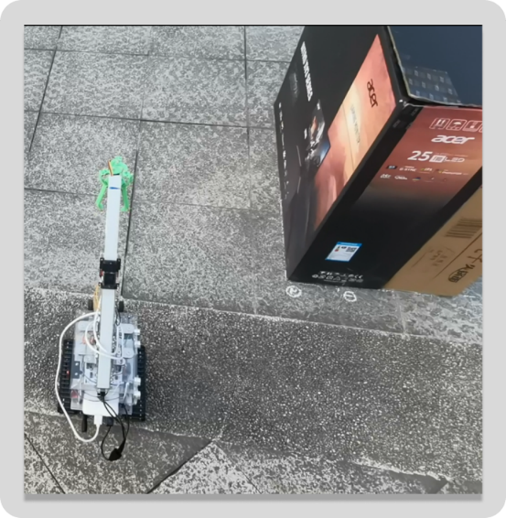

Figure . Ultrasonic recognition of obstacles and 90 degree turns.

The bridge is rectangular in shape and four vertical upward rods exist at the four corners of the rectangle. After a 90 degree turn, the direction of travel of the robot is not necessarily perpendicular to the plane formed by the two nearest poles to the upper bridge slope, and there may be a slight error. This error is magnified by the fact that the robot is positioned at a considerable distance from the upper bridge slope, and after a period of travel. If this error is not corrected, the robot may not be able to move up the upper bridge slope, or may travel in a bad direction of travel on the upper bridge slope.

Therefore, after the robot has turned 90 degrees, we let it travel forward again for 1.2s and stopped, adjusting the robot's forward direction in situ by means of the ultrasonic sensors on the right side (the plane of the obstacle is parallel to the plane of the right side of the bridge).

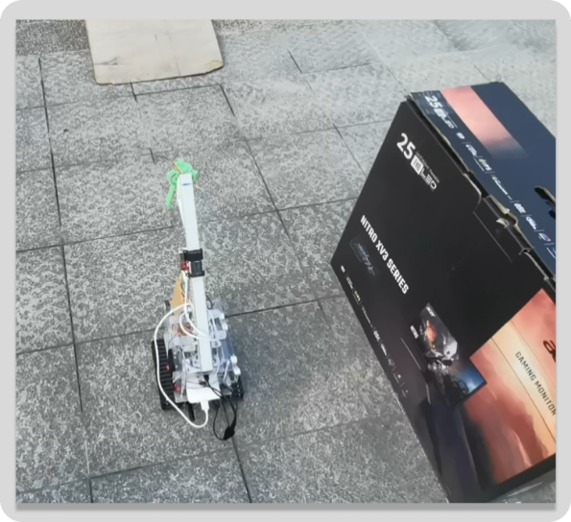

Figure . Traveling forward again for 1.2s and stopped, adjusting the forward direction.

After adjusting the forward direction, the robot enters the second loop shown in the flowchart. In this loop, the robot constantly adjusts itself via the JY60 (the angular accelerometer and gyroscope) so that it can move in a straight line. When either of the two ultrasonic sensors on the right side detects the rod on the bridge, the robot will jump out of this loop.

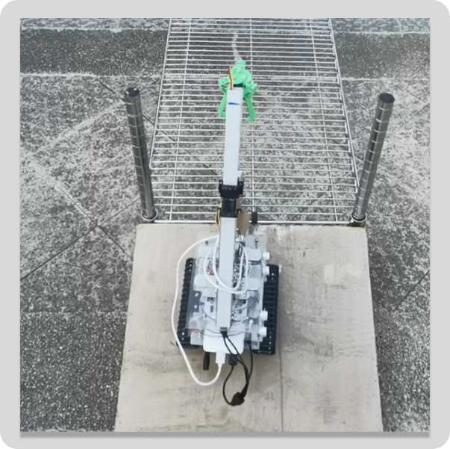

Figure . Getting on the bridge.

The bridge deck between the ramps will consist of barbed wire. Once the robot is on the bridge, the gaps between the tracks are partially embedded in the wire mesh, thus again correcting the robot's direction of travel. So, we can just keep the robot moving in a straight line over the bridge.

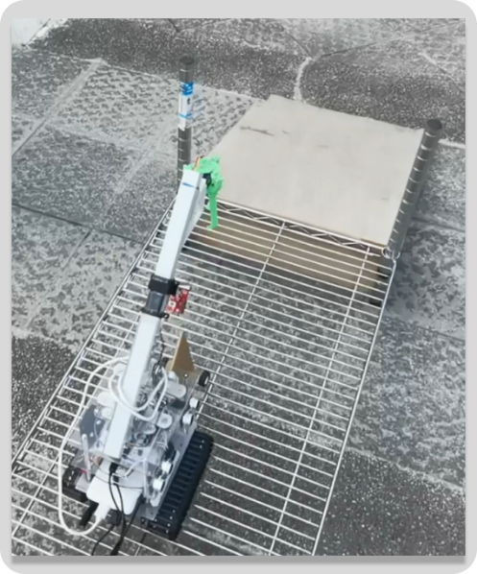

Figure . Crossing the bridge.

Once the robot is off the bridge and recognize the coloured tiles, it goes into the third loop shown in the flowchart. The third loop is similar to the first loop: OpenMV continuously identifies the coloured tiles and sends the processed information to the MCU, which in turn sends control signals to the motors for line tracking. During this loop, the two ultrasonic sensors on the right side of the robot are also constantly checking the distance to the gate frames. When the distance detected by one of the ultrasonic sensors is less than 30 cm, i.e. when the robot has crossed the gate (purple) shown in Figure 32, the robot exits the third loop.

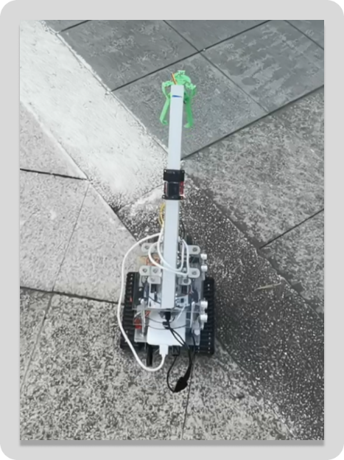 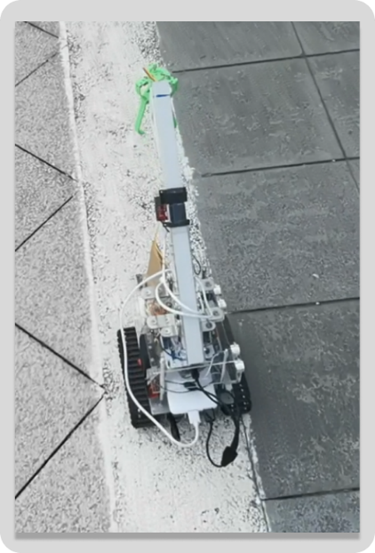

Figure . Line tracking after getting off the bridge.

Finally, after passing through the gate, the robot will keep travelling forward for 2s and stop.

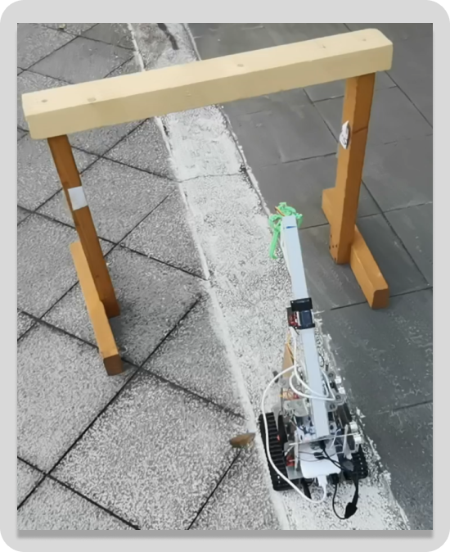

Figure . Passing through the gate.

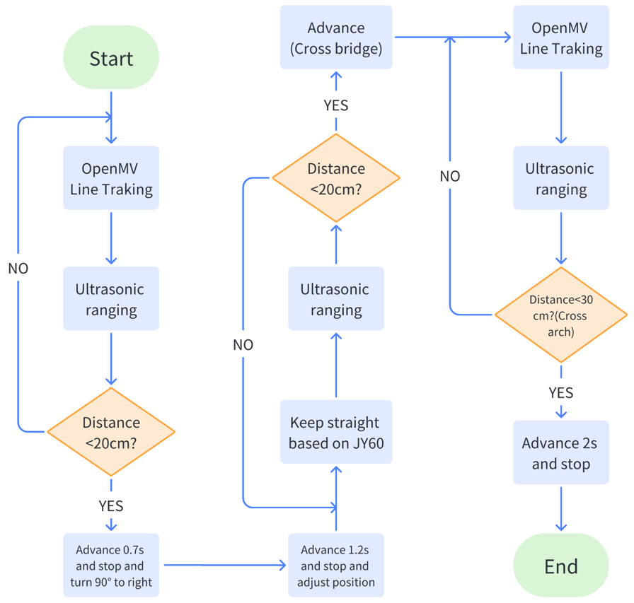

Figure . The patio 1 flow diagram.

* + - 1. Patio 2

The patio 2 tracked route is shown in Figure 41. Starting from the starting point (green), the robot will move to the yellow square where it would scan and identify the shapes on the squares to determine the direction and then knock out a bracket with matching shape in positions 1, 2 and 3.

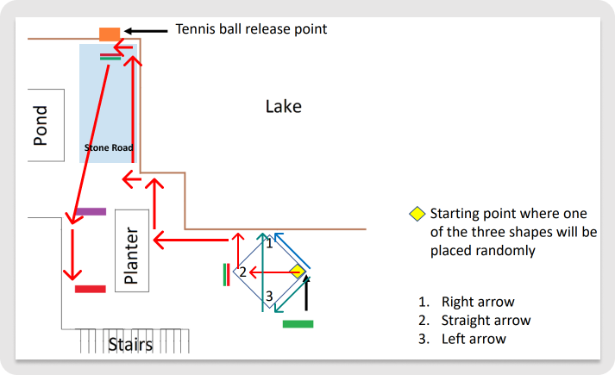

Figure . Patio 2 tracked route.

* 1. Results and Discussion
     1. Arrow Identification

In task1, the robot will stop in front of the sign and identify the arrow on the sign, but OpenMV may identify the arrow incorrectly. In order to ensure that OpenMV sends the correct arrow recognition result to the MCU, we extend the time that the robot stays in front of the sign. This allows OpenMV to perform multiple recognitions, of which the one with the highest number of occurrences is the final result. The robot then behaves accordingly to this result.

* + 1. Line Patrol
       1. Straight Line Movement

In our field tests, we found that if the robot is only able to move in a straight line by controlling the rotation of the wheels, the robot will deviate from the straight direction after a certain period of time. To solve this problem, we chose to use the accelerometer to assist with this function: before starting to move in a straight line, the direction of the robot was read from the accelerometer as the initial direction. After this, the robot would adjust the wheels according to the difference between the real time direction and the initial direction to ensure that the robot could move in a straight line.

**Patrolling along the railings**

As shown in Figure 41, in some stages, the robot will patrol the line along the railings, this is achieved by means of ultrasonic sensors mounted on the right side of the trolley. In the original solution, the robot would stop and reorient itself to be parallel to the railing before continuing on its way. However, after field tests this was found to be very time consuming. In the end we chose to reorient the robot as it travelled and to ensure that there was a fixed distance between the robot and the railing. With this improvement, the robot was able to do a good job of moving along the railings.

* + - 1. Crossing the stone road

The robot needed to cross the stone road after releasing the tennis ball. The area of the stone road (blue) and the route of travel in this area (red arrow) is shown in Figure 42. When the robot is running on the stone road, large bumps occur. At this point the ultrasonic modules' recognition of the distance to side objects can be very unstable and the robot has difficulty using this data to make adjustments to its direction of travel. As the robot only needs to travel in a straight line on the gravel road (except for turns), we have chosen to use the accelerometer directly to assist the robot to travel in a straight line through this area.

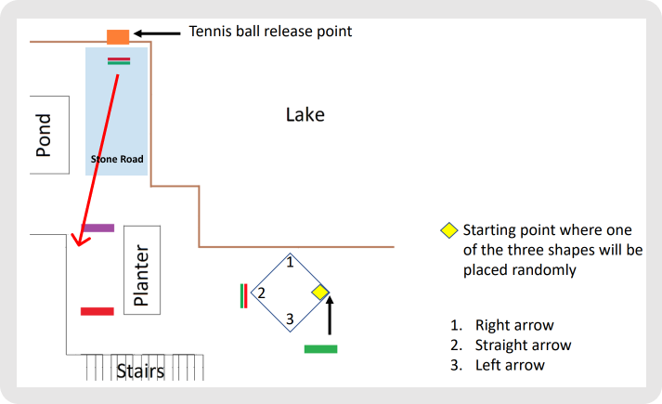

Figure . Patio 2 – the stone road.

* + - 1. Turning

At first, we fixed the parameters that control the robot's turns. However, we found that as the running time increased and the battery power decreased, the robot would lose power. In order to get it to turn in the right direction, these parameters need to be modified. This suggests that these parameters will be time dependent. To solve this problem, we chose to use the angle information from the accelerometer to assist the robot in turning.

* + 1. Wireless Communication
       1. Communication message garbling problems

In field operations, we found two reasons for messy messages:

(1). Due to the large bumps of the robot on the gravel road, the enable pin of the control communication system can come into contact with other pins, which in turn can cause garbled code problems. Therefore, we wrapped the pin with insulating tape.

(2). The DS1302 clock module, the HC-12 communication module and the L432KC do not share a common ground pin.

* + - 1. How to start sending messages

We chose to place a marker in the communication area. As soon as this object is recognised by the ultrasonic module at the front of the robot, the robot sends a message to the laptop.

* 1. Conclusion

1. References

[1] “OpenMV Cam H7,” *OpenMV*. https://openmv.io/products/openmv-cam-h7 (accessed May 20, 2023).

[2] “HCSR04.pdf.” Accessed: May 20, 2023. [Online]. Available: https://cdn.sparkfun.com/datasheets/Sensors/Proximity/HCSR04.pdf

[3] “NUCLEO-G474RE - STM32 Nucleo-64 development board with STM32G474RE MCU, supports Arduino and ST morpho connectivity - STMicroelectronics.” https://www.st.com/en/evaluation-tools/nucleo-g474re.html (accessed May 20, 2023).

[4] “ss8050-d.pdf.” Accessed: Apr. 25, 2023. [Online]. Available: https://www.onsemi.com/download/data-sheet/pdf/ss8050-d.pdf

[5] “L298N pdf, L298N Description, L298N Datasheet, L298N view ::: ALLDATASHEET :::” https://pdf1.alldatasheet.com/datasheet-pdf/view/22440/STMICROELECTRONICS/L298N.html (accessed Apr. 26, 2023).

[6] alldatasheet.com, “TB6612FNG Datasheet(PDF) - Toshiba Semiconductor.” https://www.alldatasheet.com/datasheet-pdf/pdf/807693/TOSHIBA/TB6612FNG.html (accessed Apr. 11, 2023).

[7] “MG513 Datasheet, PDF - Alldatasheet.” https://www.alldatasheet.com/view.jsp?Searchword=MG513 (accessed May 20, 2023).

1. Appendix
   * + - 1. Gantt Chart
         2. Programming

Ultrasonic Sensors

Ultrasonic Sensors Definition

1. /**

2. * @author Nestor Pereira-Neto Team: SalvadorEngenharia

3. *

4. * @section LICENSE

5. *

6. * Copyright (c) 2010 ARM Limited

7. *

8. * Permission is hereby granted, free of charge, to any person obtaining a copy

9. * of this software and associated documentation files (the "Software"), to deal

10. * in the Software without restriction, including without limitation the rights

11. * to use, copy, modify, merge, publish, distribute, sublicense, and/or sell

12. * copies of the Software, and to permit persons to whom the Software is

13. * furnished to do so, subject to the following conditions:

14. *

15. * The above copyright notice and this permission notice shall be included in

16. * all copies or substantial portions of the Software.

17. *

18. * THE SOFTWARE IS PROVIDED "AS IS", WITHOUT WARRANTY OF ANY KIND, EXPRESS OR

19. * IMPLIED, INCLUDING BUT NOT LIMITED TO THE WARRANTIES OF MERCHANTABILITY,

20. * FITNESS FOR A PARTICULAR PURPOSE AND NONINFRINGEMENT. IN NO EVENT SHALL THE

21. * AUTHORS OR COPYRIGHT HOLDERS BE LIABLE FOR ANY CLAIM, DAMAGES OR OTHER

22. * LIABILITY, WHETHER IN AN ACTION OF CONTRACT, TORT OR OTHERWISE, ARISING FROM,

23. * OUT OF OR IN CONNECTION WITH THE SOFTWARE OR THE USE OR OTHER DEALINGS IN

24. * THE SOFTWARE.

25. *

26. * @section DESCRIPTION

27. *

28. * Biblioteca para uso do sonar HC-SR04, possui rotinas para permitir medições

29. * de distências retornado valores em centímetros, polegadas ou o tempo

30. * percorrido pelo som (em microsegundos).

31. * Esta biblioteca pode ser usada com qualquer pino do microcontrolador.

32. */

33.

34.

35. #include "HCSR04.h"

36. #include "mbed.h"

37.

38.

39. HCSR04::HCSR04(PinName trigger, PinName echo) : _t(trigger), _e(echo) {

40. thread_sleep_for(100);

41. }

42.

43. float HCSR04::getCm(void){

44. distcm = readEcho()/58;

45. return distcm;

46. }

47.

48. float HCSR04::getIn(void){

49. distin = readEcho()/148;

50. return distin;

51. }

52.

53. float HCSR04::readEcho(void){

54. _t=1; //Inicio do trigger

55. wait_us(10); //10us de pulso

56. _t=0; //Fim do trigger

57. while(!_e);

58. _tempo.start();

59. while(_e);

60. tdist = _tempo.read_us(); //Leitura do tempo transcorrido

61. _tempo.stop(); //Paro o temporizador

62. _tempo.reset(); //Reset para o próximo ciclo

63. return tdist;

64. }

Ultrasonic Sensors Header File

1. /**

2. * @author Nestor Pereira-Neto Team: SalvadorEngenharia

3. *

4. * @section LICENSE

5. *

6. * Copyright (c) 2010 ARM Limited

7. *

8. * Permission is hereby granted, free of charge, to any person obtaining a copy

9. * of this software and associated documentation files (the "Software"), to deal

10. * in the Software without restriction, including without limitation the rights

11. * to use, copy, modify, merge, publish, distribute, sublicense, and/or sell

12. * copies of the Software, and to permit persons to whom the Software is

13. * furnished to do so, subject to the following conditions:

14. *

15. * The above copyright notice and this permission notice shall be included in

16. * all copies or substantial portions of the Software.

17. *

18. * THE SOFTWARE IS PROVIDED "AS IS", WITHOUT WARRANTY OF ANY KIND, EXPRESS OR

19. * IMPLIED, INCLUDING BUT NOT LIMITED TO THE WARRANTIES OF MERCHANTABILITY,

20. * FITNESS FOR A PARTICULAR PURPOSE AND NONINFRINGEMENT. IN NO EVENT SHALL THE

21. * AUTHORS OR COPYRIGHT HOLDERS BE LIABLE FOR ANY CLAIM, DAMAGES OR OTHER

22. * LIABILITY, WHETHER IN AN ACTION OF CONTRACT, TORT OR OTHERWISE, ARISING FROM,

23. * OUT OF OR IN CONNECTION WITH THE SOFTWARE OR THE USE OR OTHER DEALINGS IN

24. * THE SOFTWARE.

25. *

26. * @section DESCRIPTION

27. *

28. * Biblioteca para uso do sonar HC-SR04, possui rotinas para permitir medições

29. * de distências retornado valores em centímetros, polegadas ou o tempo

30. * percorrido pelo som (em microsegundos).

31. * Esta biblioteca pode ser usada com qualquer pino do microcontrolador.

32. */

33.

34.

35. #ifndef HCSR04_H

36. #define HCSR04_H

37.

38. #include "mbed.h"

39.

40.

41.

42. /**

43. * Sonar HC-SR04 example.

44. * @code

45. * #include "mbed.h"

46. * #include "HCSR04.h"

47. *

48. * DigitalOut myled(LED1);

49. * Serial pc(USBTX,USBRX);

50. *

51. * HCSR04 sonar(PTD5, PTA13);

52. *

53. * int main() {

54. * while(1) {

55. * printf("Distancia detectada pelo sensor Frente %.2f cm \n", sonar.getCm());

56. * wait_ms(1000);

57. * }

58. * }

59. *

60. * @endcode

61. */

62.

63. class HCSR04 {

64. public:

65. /** Constructor, create HCSR04 instance

66. *

67. * @param trigger TRIG pin

68. * @param echo ECHO pin

69. */

70. HCSR04(PinName trigger, PinName echo);

71.

72. /** It make a reading of the sonar Faz uma leitura do sonar

73. *

74. * @returns Tempo do pulso echo em microsegundos*/

75. float readEcho(void);

76.

77. /** It messures the distance in centimeter "cm"

78. *

79. *@returns Distance in centimeter

80. */

81. float getCm(void);

82.

83. /** Mede a distência em polegadas "in"

84. *

85. *@returns Distência em in*/

86. float getIn(void);

87.

88. private:

89. float tdist; //Leitura do tempo transcorrido

90. float distcm; //Guarda o valor da distanciância em centímetros

91. float distin; //Guarda o valor da distência em polegadas

92.

93. DigitalOut _t; //Configuração do pino de Trigger

94. DigitalIn _e; //Configuração do pino de Echo

95. Timer _tempo; //Cria um objeto timer

96.

97. };

98.

99. #endif

Accelerometer and Gyroscope

Accelerometer and Gyroscope Definition

1. #include "JY60.h"

2.

3. UnbufferedSerial device(A4,A5); // tx, rx

4. unsigned char Re_buf[11],counter=0;

5. unsigned char sign=0;

6. float yaw1 = 0;

7. float yaw2 = 0;

8. int GetData1=0;

9. int GetData2=0;

10. float DeltaAngle=0;

11. float FinishFlag=0;

12.

13. void StartdeviceEvent() {

14. //Re_buf[counter]=(unsigned char)device.getc();

15. (unsigned char)device.read(&Re_buf[counter],sizeof(Re_buf[counter]));

16. //if(counter==0&&Re_buf[0]!=0x55) return; // Data No. 0 is not a frame header

17. if(counter!=0||Re_buf[0]==0x55){

18. counter++;

19. if(counter==11) // Receive 11 data

20. {

21. counter=0; // Reassignment in preparation for the next frame of data to be received

22. sign=1;

23. }

24. // Attitude resolution starts when a complete data frame is received

25. if(sign)

26. {

27. sign=0;

28. if(Re_buf[0]==0x55) // Checking the frame header

29. {

30. static float lastYaw = 0;

31. static float turnNum = 0;

32. if(Re_buf [1]==0x53)

33. {

34. yaw1=0;

35. double yaw_;

36. yaw_ = Re_buf[7] << 8 | Re_buf[6];

37. yaw_ = yaw_ / 32768.0 * 180;

38. if(lastYaw < 90 && yaw_ > 270){turnNum -= 1;}

39. else if(lastYaw > 270 && yaw_ < 90){turnNum += 1;}

40. lastYaw = yaw_;

41. yaw1 = yaw_ + 360*turnNum;

42. GetData1=1;

43. }

44. else GetData1=0;

45. }

46. }

47. }

48. }

49.

50. void EnddeviceEvent() {

51. //Re_buf[counter]=(unsigned char)device.getc();

52. (unsigned char)device.read(&Re_buf[counter],sizeof(Re_buf[counter]));

53. //if(counter==0&&Re_buf[0]!=0x55) return; // Data No. 0 is not a frame header

54. if(counter!=0||Re_buf[0]==0x55){

55. counter++;

56. if(counter==11) // Receive 11 data

57. {

58. counter=0; // Reassignment in preparation for the next frame of data to be received

59. sign=1;

60. }

61. // Attitude resolution starts when a complete data frame is received

62. if(sign)

63. {

64. sign=0;

65. if(Re_buf[0]==0x55) // Checking the frame header

66. {

67. static float lastYaw = 0;

68. static float turnNum = 0;

69. if(Re_buf [1]==0x53)

70. {

71. yaw2=0;

72. double yaw_;

73. yaw_ = Re_buf[7] << 8 | Re_buf[6];

74. yaw_ = yaw_ / 32768.0 * 180;

75. if(lastYaw < 90 && yaw_ > 270){turnNum -= 1;}

76. else if(lastYaw > 270 && yaw_ < 90){turnNum += 1;}

77. lastYaw = yaw_;

78. yaw2 = yaw_ + 360*turnNum;

79. DeltaAngle = abs(yaw2-yaw1);

80. GetData2=1;

81. }

82. else GetData2=0;

83. }

84. }

85. }

86. }

Accelerometer and Gyroscope Header File

1. #ifndef GYRO_H

2. #define GYRO_H

3. #include "mbed.h"

4.

5. extern float yaw1;

6. extern float yaw2;

7. extern int GetData1;

8. extern int GetData2;

9. extern float DeltaAngle;

10. extern float FinishFlag;

11. //extern float a_x, a_y, a_z;

12. void StartdeviceEvent();

13. void EnddeviceEvent();

14. #endif

Patio 1 Main Program

1. /* mbed Microcontroller Library

2. * Copyright (c) 2019 ARM Limited

3. * SPDX-License-Identifier: Apache-2.0

4. */

5. #include "mbed.h"

6. #include "platform/mbed_thread.h"

7. #include "HCSR04.h"

8. #include "JY60.h"

9.

10. BufferedSerial HC(D1,D0,115200); // Serial communication with OpenMV

11.

12. char buf[32]={0};

13.

14.

15. DigitalOut in1(D2);

16. DigitalOut in2(D3);

17. DigitalOut in3(D4);

18. DigitalOut in4(D5);

19. PwmOut left(D6);

20. PwmOut right(D7);

21.

22. PwmOut Claw(A0);

23.

24. HCSR04 sensor1(D8, D9);// front supersonic sensor, trig, echo

25. HCSR04 sensor2(D10, D11);// left supersonic sensor1

26. HCSR04 sensor3(D12, D13);// left supersonic sensor2

27. float diff;// Ultrasonic gap measurement

28.

29. float distance1,distance2,distance3;

30. float TurnDistance=30;

31. float StopDistance=30;

32. char left_speed,right_speed;

33. char left_label,right_label;

34. int num;

35. float coeff;

36. float startangle=-90;

37.

38. void init()

39. {

40.

41. left.write(0.0);

42. right.write(0.0);

43. in1=0;

44. in2=0;

45. in3=0;

46. in4=0;

47. left_speed=0;

48. right_speed=0;

49. left_label=2;

50. right_label=2;

51. }

52. void run()

53. {

54. left_speed=int(left_speed);

55. right_speed=int(right_speed);

56. left_label=int(left_label);

57. right_label=int(right_label);

58. if((left_label==0 || left_label==1) &&(right_label==0 ||right_label==1)){

59. if (left_label==0){

60. in3=0;

61. in4=1;

62. left_speed=left_speed-256;

63. }else{

64. in3=1;

65. in4=0;

66. }

67. float left_data=float(abs(left_speed)/100.0);

68. left.write(left_data);

69. if (right_label==0){

70. in1=1;

71. in2=0;

72. right_speed=right_speed-256;

73. }else{

74. in1=0;

75. in2=1;

76. }

77. float right_data=float(abs(right_speed)/100.0);

78. right.write(right_data);

79. }else{

80. left.write(0.0);

81. right.write(0.0);

82. }

83. }

84. void getdata_pack()

85. {

86. num=HC.read(buf,sizeof(buf));// read the data sent by OpenMV and store them in buf

87. // assign the data to different parameters

88. left_speed=buf[0];

89. right_speed=buf[1];

90. left_label=buf[2];

91. right_label=buf[3];

92. }

93. void angle()//JY60 angle measurement

94. {

95. while (true)

96. {

97. StartdeviceEvent();

98. if(GetData1)

99. {

100. break;

101. }

102. }

103. }

104. void forwardinline()

105. {

106. angle();

107. coeff = 0.001*abs(yaw1-startangle)+0.02;// Set a deflection factor that decreases with increasing distance difference of the deflection, but does not exceed 0.1 maximum

108. if(coeff > 0.1){

109. coeff = 0.1;

110. }

111. if(yaw1 > startangle){// Off to the left of a straight line

112. left.write(0.36-2*coeff);

113. right.write(0.30+2*coeff);

114. }

115. else if(yaw1 < startangle){// Off to the right of a straight line

116. left.write(0.36+2*coeff);

117. right.write(0.30-2*coeff);

118. }

119. }

120. int main()

121. {

122. init();

123. while(true)// task1

124. {

125. if(sensor2.getCm()<TurnDistance&&sensor3.getCm()<TurnDistance)// Two ultrasonic modules on the side detect the markers simultaneously

126. {

127. thread_sleep_for(1500);// Continue on past the marker

128. // Start of the turn

129. in1=0;

130. in2=0;

131. in3=0;

132. in4=0;

133. thread_sleep_for(500);// Stop before the start of the turn to prevent acceleration effects

134.

135. while(true)

136. {

137. StartdeviceEvent();

138. if(GetData1)

139. {

140. break;

141. }

142. }

143. in2=1;

144. in4=1;

145. left.write(0.35);

146. right.write(0.35);

147. // Judging the moment to stop the turn

148. while(true)

149. {

150. if(DeltaAngle>80||DeltaAngle==80)

151. {

152. DeltaAngle=0;

153. break;

154. }// Turn stops at 90 degrees, jump out of cycle, otherwise continue turning

155. else{

156. while (true)

157. {

158. EnddeviceEvent();

159. if(GetData2)// Jump out of the loop when data is received

160. {

161. break;

162. }

163. }

164. }

165. }// End of turn

166.

167. in2=0;

168. in4=0;

169. thread_sleep_for(1000);// Stop for a while after the end of the turn

170. break;// Jump out of the loop and end task1

171. }

172.

173. else// Conduct task1 rounds

174. {

175. getdata_pack();

176. run();

177. }

178. }

179. // Straight ahead before going onto the bridge

180. // First level the robot by ultrasound, the distance is not important, but it must be level

181. in1=1;

182. in2=0;

183. in3=0;

184. in4=1;

185. left.write(0.45);

186. right.write(0.4);

187. thread_sleep_for(2000);// A period of time forward at the end of the turn

188.

189. in1=0;

190. in2=0;

191. in3=0;

192. in4=0; // Stop to start position adjustment

193. thread_sleep_for(1000);

194.

195. // Leveling the robot using ultrasound

196. while(true)

197. {

198. diff=sensor2.getCm()-sensor3.getCm();

199. if(abs(diff)<0.5){

200. break;// Consider the robot level and jump out of the loop

201. }

202. else if(diff<-0.5)

203. {

204. in1=1;

205. in2=0;

206. in3=1;

207. in4=0;

208. left.write(0.25);

209. right.write(0.25);

210. thread_sleep_for(100);

211. }

212. else if(diff>0.5)

213. {

214. in1=0;

215. in2=1;

216. in3=0;

217. in4=1;

218. left.write(0.25);

219. right.write(0.25);

220. thread_sleep_for(100);

221. }

222. }

223. // Start on the bridge

224.

225. in1=1;

226. in2=0;

227. in3=0;

228. in4=1;

229. while(true)

230. {

231. if(sensor2.getCm()<30||sensor3.getCm()<30)// Jump out of the loop and start going straight when the robot recognise the railings on the bridge

232. {

233. break;

234. }

235. else

236. {// Adjust the robot's position if it doesn't recognise the railing on the bridge

237. forwardinline();

238. }

239. }

240.

241. left.write(0.48);

242. right.write(0.40);

243. thread_sleep_for(17000);

244. // The robot over bridge

245. in1=1;

246. in2=0;

247. in3=1;

248. in4=0;

249. left.write(0.3);

250. right.write(0.3);

251. thread_sleep_for(1100);// Deflected at an angle to facilitate OpenMv recognition

252. while(true)

253. {

254.

255. if(sensor2.getCm()<StopDistance||sensor3.getCm()<StopDistance)

256. {

257. in1=1;

258. in2=0;

259. in3=0;

260. in4=1;

261. left.write(0.4);

262. right.write(0.45);

263. thread_sleep_for(2000);

264. in1=0;

265. in2=0;

266. in3=0;

267. in4=0;

268. break;

269. }

270. else

271. {

272. getdata_pack();

273. run();

274. }

275. }

276. }

* + - * 1. Project Management

Table . PCB bill of materials.

|  |  |  |  |  |  |
| --- | --- | --- | --- | --- | --- |
| Comment | Description | Designator | Footprint | LibRef | Quantity |
| 10uf | General Purpose Ceramic Capacitor, 0402, 10uF | C1, C7, C9, C10, C11 | FP-0402-L_1_0_1-W_0_5_0_1-IPC_B | CMP-1034-02125-3 | 5 |
| 2.2uf | General Purpose Ceramic Capacitor, 0402, 2.2uF | C2 | FP-0402-L_1_0_1-W_0_5_0_1-IPC_B | CMP-1034-02125-3 | 1 |
| 0.1uf | General Purpose Ceramic Capacitor, 0402, 0.1uF | C3, C6, C8, CBS | FP-0402-L_1_0_1-W_0_5_0_1-IPC_B | CMP-1034-02125-3 | 4 |
| 22uF | Chip Multilayer Ceramic Capacitors for General Purpose, 0805, 22uF, X5R, 15%, 20%, 25V | C4, C5 | FP-GRM21B-0_15-IPC_B | CMP-2007-03385-2 | 2 |
| 200pf | General Purpose Ceramic Capacitor, 0402, 200pF, 10%, X5R, 15%, 6.3V | CFF | FP-0402-L_1_0_1-W_0_5_0_1-IPC_B | CMP-1034-02125-3 | 1 |
| blue | Blue LED, 10 mA, 3.9 V, -40 to 100 degC, 2-Pin SMD (0603), RoHS, Tape and Reel | DS1 | VISH-TLMX1100-2_V | CMP-1666-00028-1 | 1 |
| red | Red, LED, 2.1 V, -40 to 100 degC, 2-Pin SMD (0603), RoHS, Tape and Reel | DS2 | VISH-TLMX1100_V | CMP-1666-00027-1 | 1 |
| HDR-1X4 | Header, 4-Pin | Encoder_out | HDR2.54-LI-4P | Header 4 | 1 |
| Fuse | 25℃ 3A | F1 | F1206 | JFC1206-1300FS | 1 |
| Fuse | 25℃ 0.7A | Fuse2, Fuse3 | F1206 |  | 2 |
| USB type-A | USB 2.0 Type A Receptacle WR-COM, Horizontal, THT | J1, J2 | 61400416021 | CMP-1502-03227-1 | 2 |
| 4.7uH & 3.3uH | FIXED IND 4.7UH 4.1A 50.16 MOHM | L1 | FP-PCC-M0530M-LP-MFG | CMP-05439-000015-1 | 1 |
| Buzzer | Piezo Indicator, 4100 Hz, 3 to 16 V, -20 to 70 degC, 2-Pin THD, RoHS | LS1 | KINGS-KPEG242-2 | CMP-2000-06518-1 | 1 |
| HDR-1X6 | 6P motor connector | MotorA, MotorB | XH2.54-LS-6P | Header 6 | 2 |
| 0R | RES Thick Film, 0Ω, 1%, 100ppm/°C, 0402 | NC, R2, R8 | FP-CRCW0402-e3-IPC_C | CMP-2002-00051-3 | 3 |
| 3V3_out | Header, 6-Pin | P1 | HDR1X6 | Header 6 | 1 |